SUBCOURSE EDITION
OD0471 8

PRINCIPLES OF THE SIMPLIFIED TEST
EQUIPMENT/M1 TEST SET--M1 TANK


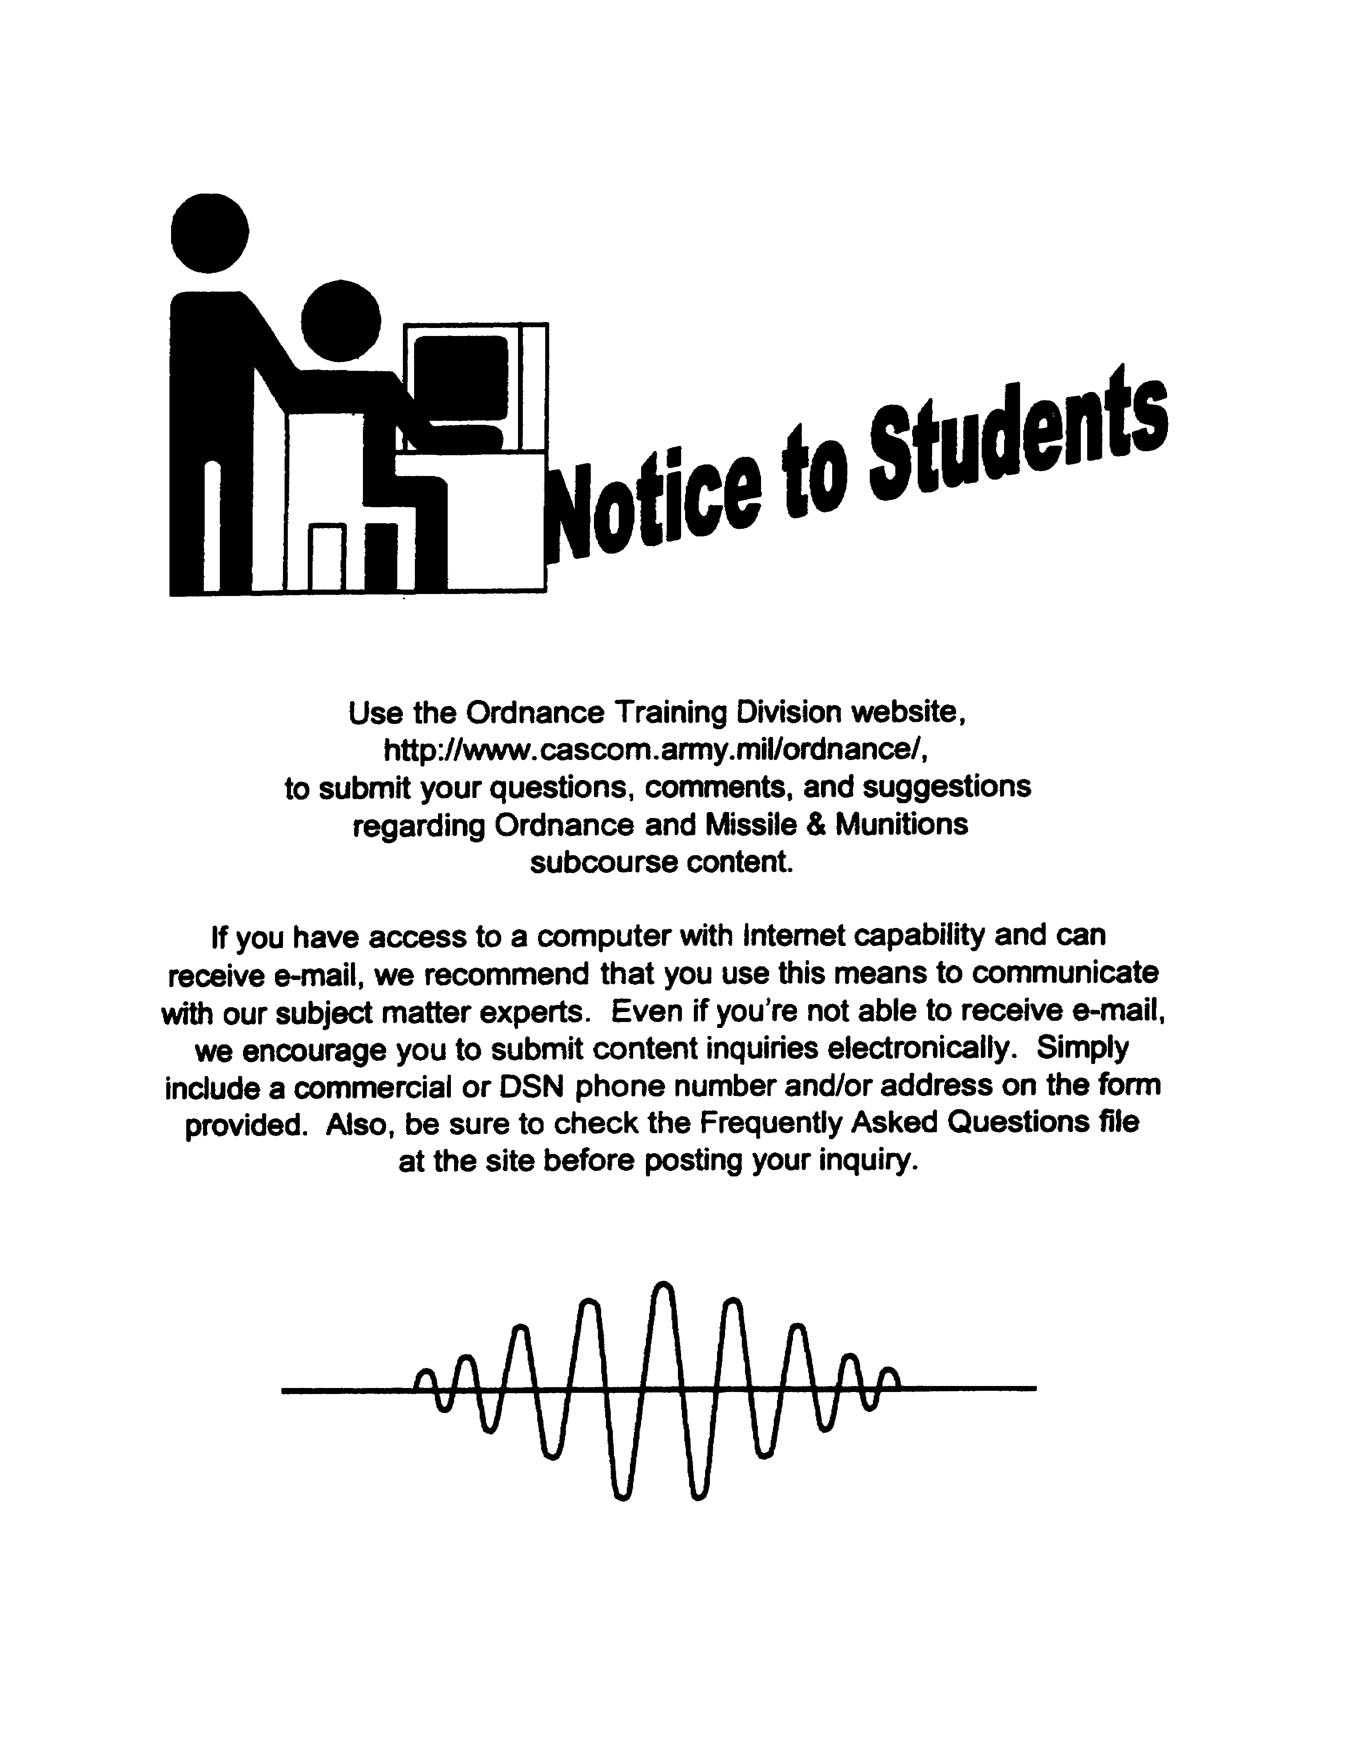

PRINCIPLES OF THE SIMPLIFIED TEST EQUIPMENT/Mi
TEST SET--Ml TANK

SUBCOURSE OD0471

United States Army Combined Arms Support Command
Fort Lee, VA 23801-1809

6 Credit Hours
NEW: 1988

GENERAL

This subcourse introduces the STE/M1-FVS test set. Both the function and the operation of the set will be discussed.

Six credit hours are awarded for successful completion of this subcourse

Lesson 1: THE FUNCTION AND OPERATION OF THE SIMPLIFIED TEST EQUIPMENT/M1 TEST SET

TASK 1: Describe the function of the simplified test equipment/Ml test set.

TASK 2: Describe the operation of the simplified test equipment/Mi test set.

i
PRINCIPLES OF STE/M1 TEST SET--M1 TANK - OD 0471

TABLE OF CONTENTS

Section Page

TITLE i

TABLE OF CONTENTS ii

Lesson 1: THE FUNCTION AND OPERATION OF THE
SIMPLIFIED TEST EQUIPMENT/M1 TEST
SET 1

Task 1: Describe the function of the
simplified test equipment/Mi test set 1

Task 2: Describe the operation of the
simplified test equipment/Mi test set 8

Practical Exercise 1 31

Answers to Practical Exercise 1 33

REFERENCES 34

ii
PRINC OF STE/M1 TEST SET--M1 TANK - OD 0471 - LESSON 1/TASK 1

LESSON 1

THE FUNCTION AND OPERATION OF THE
SIMPLIFIED TEST EQUIPMENT/Mi TEST SET

TASK 1. Describe the function of the simplified test equipment/M1 test set.

CONDITIONS

Within a self-study environment and given the subcourse text, without assistance.

STANDARDS

Within two hours

REFERENCES

No supplementary references are needed for this task.

1. Introduction

Army materiel is becoming more and more complex. With miles and miles of electrical wiring, hundreds and hundreds of electronic components, and dozens of interrelated electrical systems and subsystems, many computer-controlled, it is often the case that the M1 tank systems mechanic finds that what were once simple diagnostic tasks, requiring little more than a multimeter, are now complex chores that would take forever, unless he had a computer of his own to troubleshoot the computers on the tank.

The M1 tank systems mechanic does have such a computer available. It is the simplified test equipment/M1-FVS, commonly called the STE/M1-FVS. The STE/M1-FVS, which can be used on both the M1 tank and the M2 and M3 fighting vehicle systems, is a small computer that traces circuitry in the vehicles and identifies faulty components quickly, through the use of preprogrammed tests. The mechanic enters the appropriate test number, and the STE/M1-FVS does the rest.

1
PRINC OF STE/M1 TEST SET--M1 TANK - OD 0471 - LESSON 1/TASK 1

This task will introduce the STE/Mi-FVS, and describe how the test set functions. In addition, this task will discuss the various test assemblies, hardware, and accessories that are supplied with the instrument.

2. The STE/M1-FVS Test Set

A block diagram showing typical connections to the STE/M1-FVS test set is shown in figure 1. The test set is made up of the common hardware and the peculiar hardware. The common hardware items are used, together with the necessary peculiar hardware items, for testing all vehicles that the test set supports. The peculiar hardware items are used according to the requirements of the vehicle being tested.

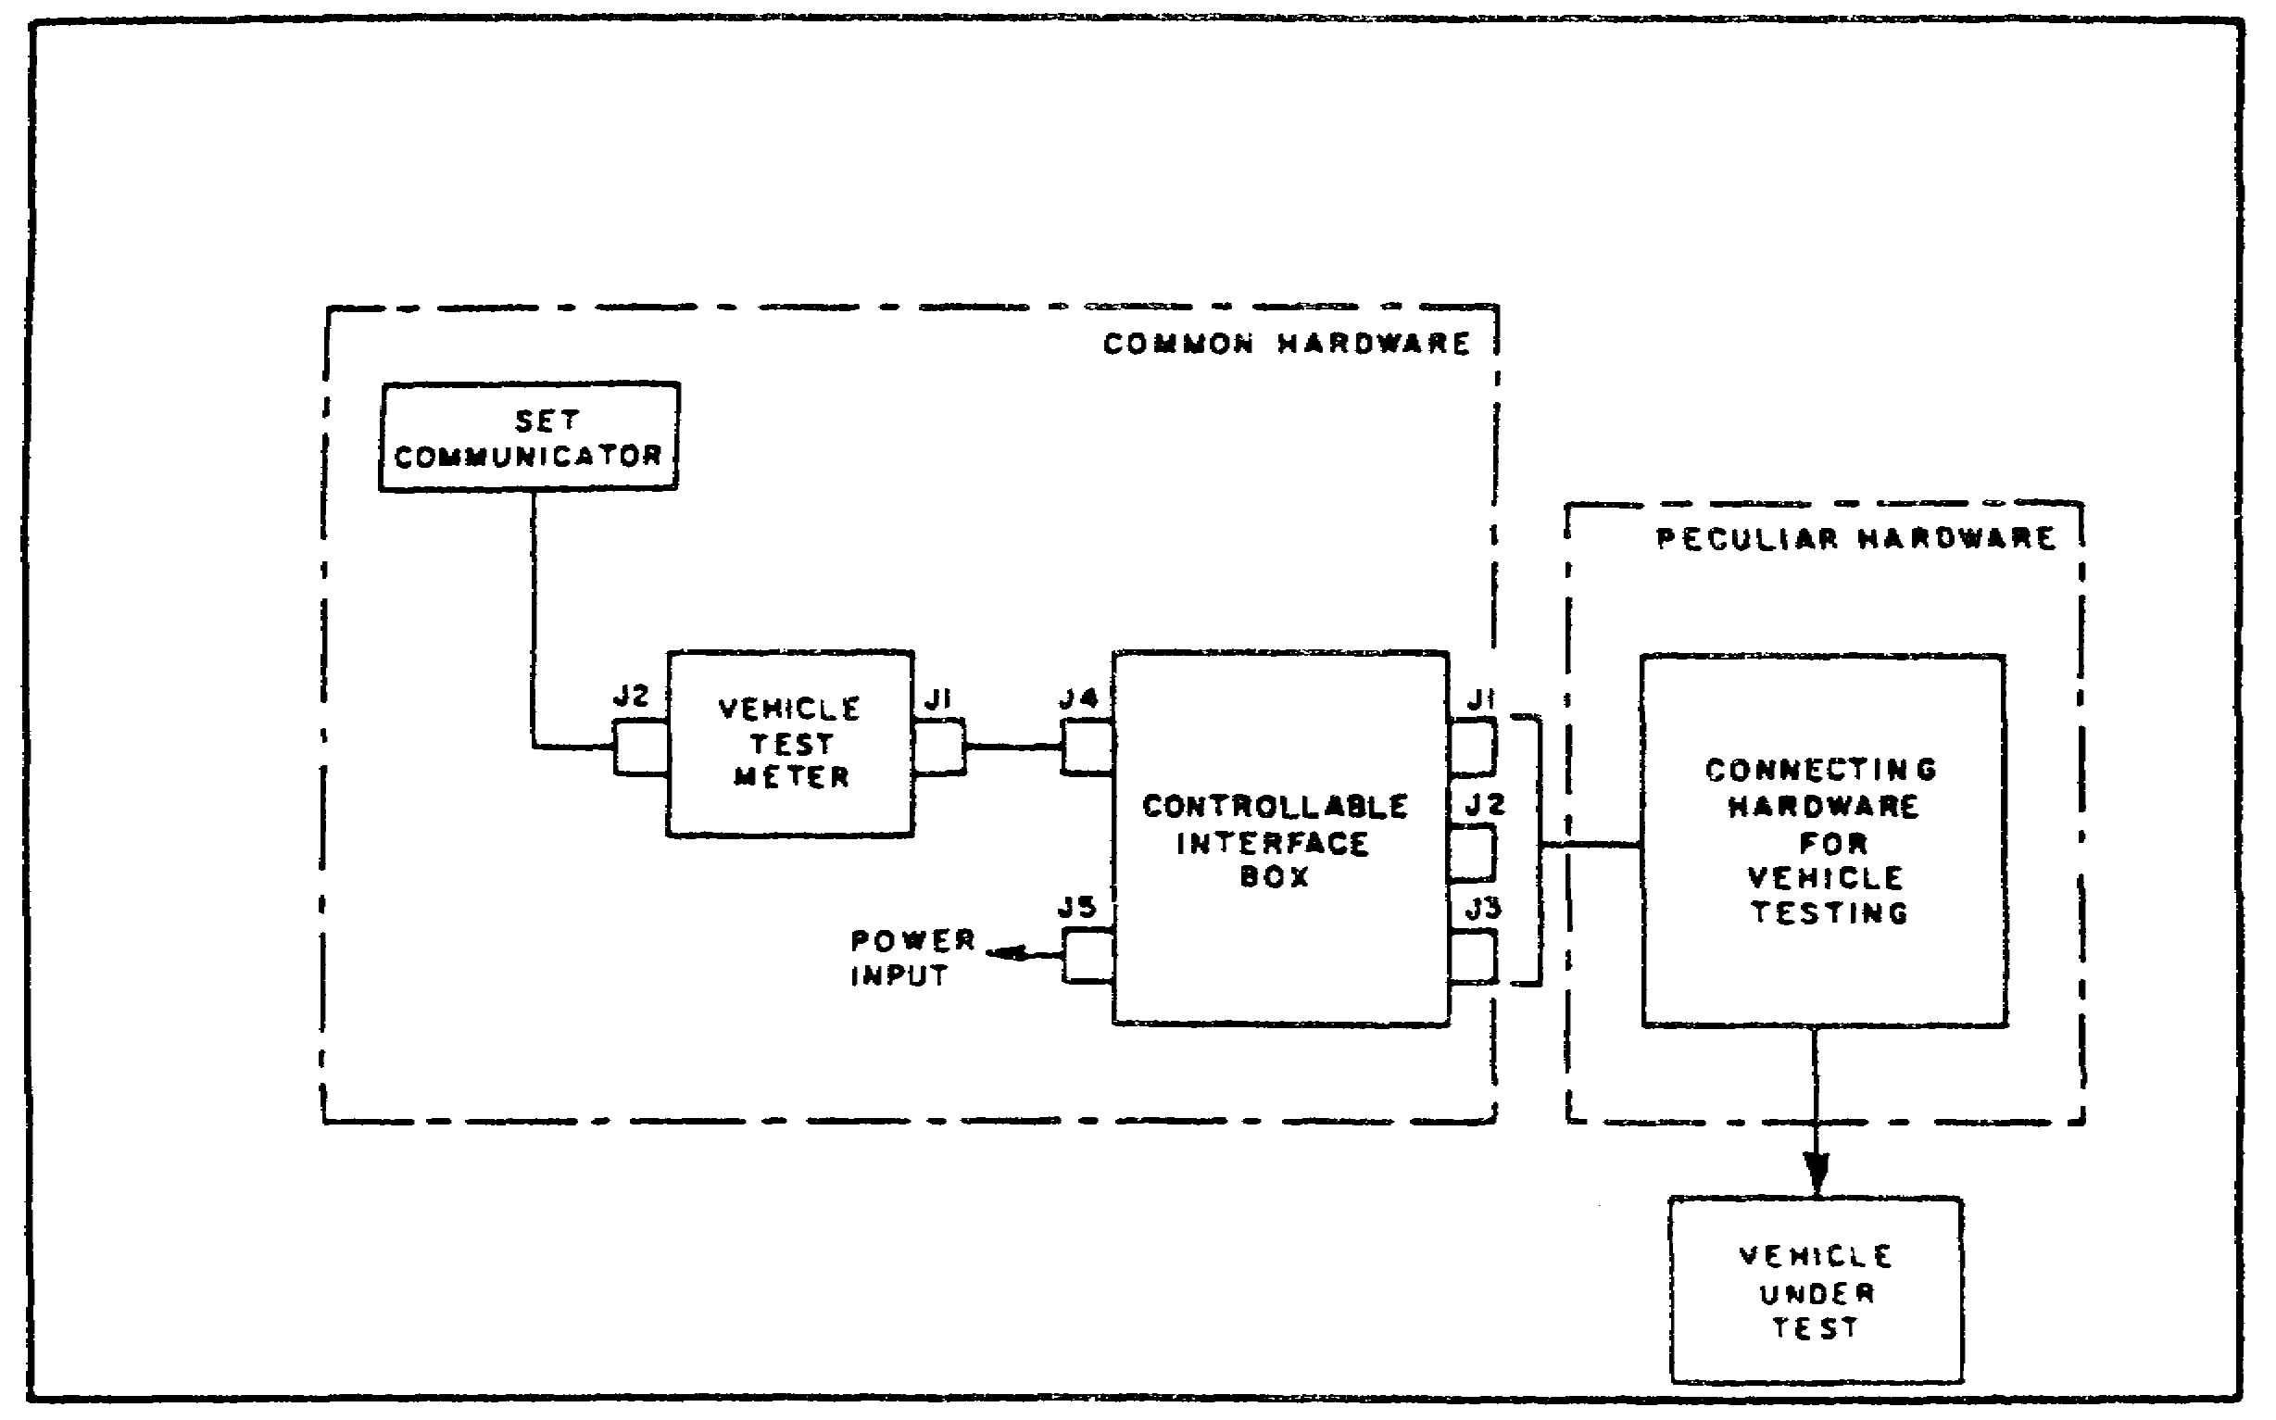

FIGURE 1. STE/M1-FVS BLOCK DIAGRAM.

Power for operating the test set is supplied by the vehicle under test. A built-in self-test is used to determine that the test set is ready for use. After the self-test, the test set is connected for vehicle tests according to the instructions in the applicable vehicle technical manual (TM). The self-test is used to identify fault symptoms in the set, and to determine if maintenance actions upon the set have corrected the problem.

2
PRINC OF STE/M1 TEST SET--M1 TANK - OD 0471 - LESSON 1/TASK 1

a. Common Hardware. The common hardware items consist of a vehicle test meter (VTM), a controllable interface box (CIB), a set communicator (SETCOM), and associated adapters and cable assemblies.

(1) Vehicle Test Meter (VTM). The VTM is shown in figure 2. The VTM is the basic unit to which the CIB and SETCOM are connected. A microprocessor within the VTM controls internal operation and data inputs and outputs. The VTM receives input power from the vehicle under test, directly or through the CIB. The VTM, in stand-alone mode, is capable of measuring voltage, resistance, current, and frequency.

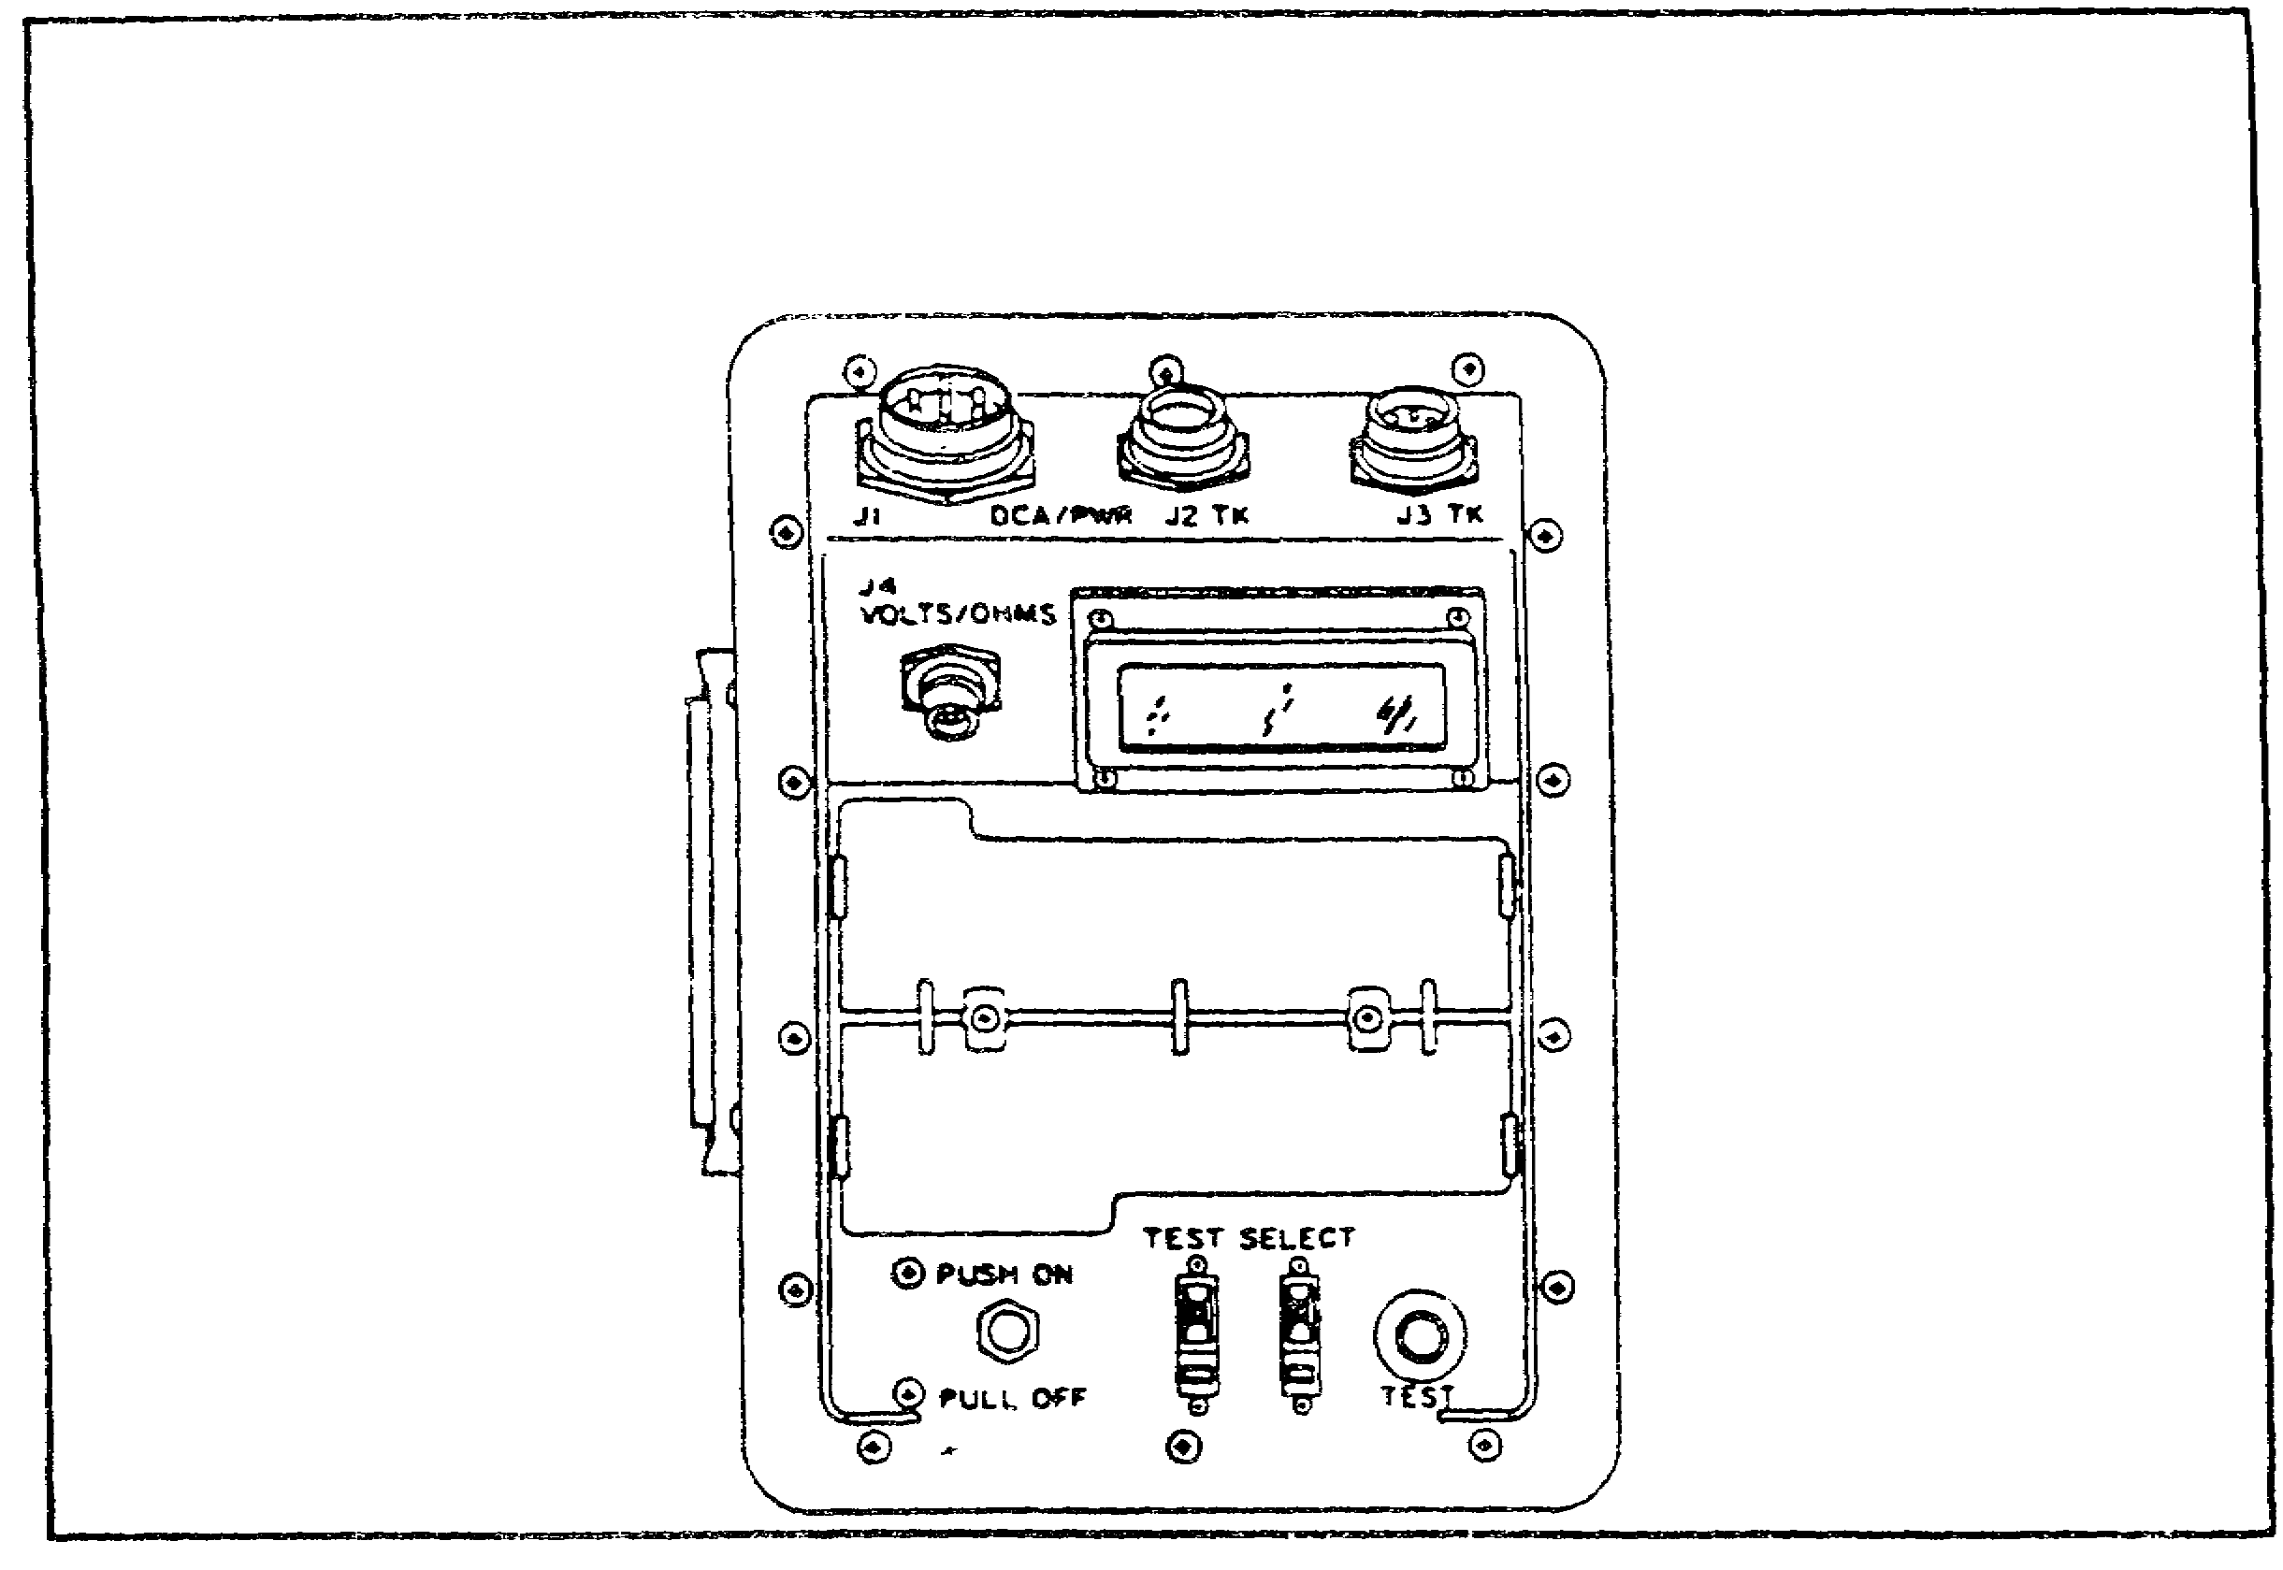

FIGURE 2. STE/Ml-FVS VEHICLE TEST METER (VTM).

(2) Controllable Interface Box (CIB). The CIB is shown in figure 3, on the following page. The CIB is connected by cables to both the VTM and the vehicle under test. Two identical 128-pin connectors, when used with the test cables and peculiar hardware items, connect to the vehicle test connectors and active junctions. The CIB also contains a microprocessor for multiplexing, communication, and power control.

3
PRINC OF STE/M1 TEST SET--M1 TANK - OD 0471 - LESSON 1/TASK 1

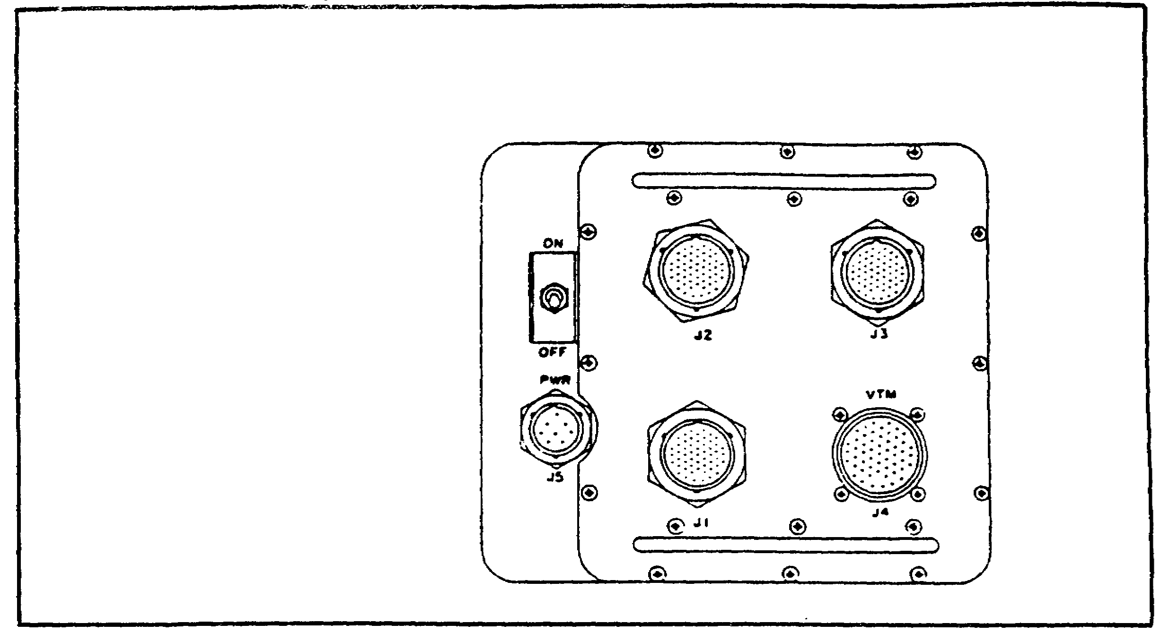

FIGURE 3. STE/M1-FVS CONTROLLABLE INTERFACE BOX (CIB).

(3) Set Communicator (SETCOM). The SETCOM, shown in figure 4, is the interface between the test set and the operator. A keyboard on the SETCOM allows the operator to communicate with the test set. These communications include input of test data, test numbers, response to observations, and commands to control test progress. The SETCOM uses a 39-character alphanumeric display to give the operator instructions and request information.

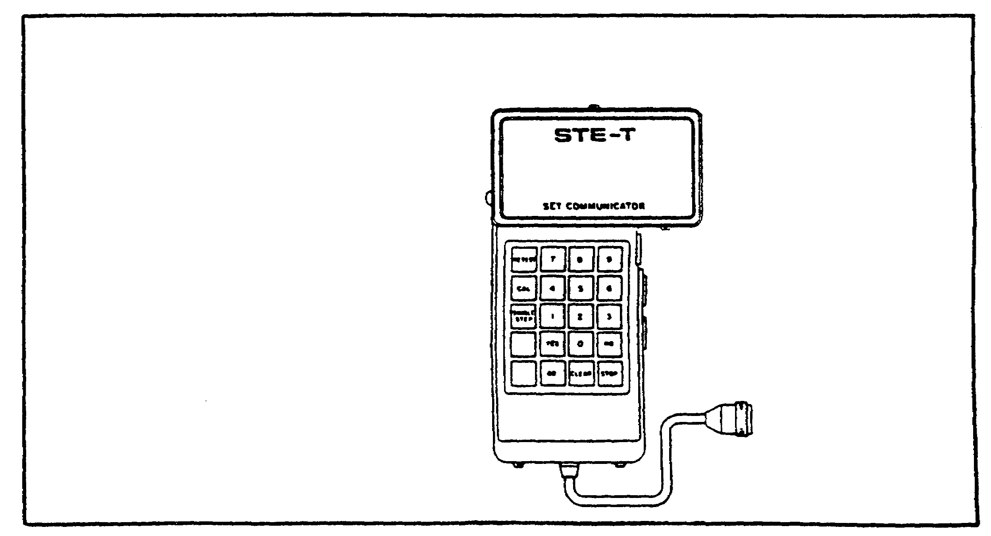

FIGURE 4. STE/M1-FVS SET COMMUNICATOR (SETCOM).

4
PRINC OF STE/M1 TEST SET--M1 TANK - OD 0471 - LESSON 1/TASK 1

b. Peculiar Hardware. The peculiar hardware items consist of cables and special adapters, to interface between the common hardware and the vehicle under test. The operator connects the cables and adapters during vehicle checkout and troubleshooting, as directed by the SETCOM. Throughout this subcourse, we will discuss in detail only that peculiar hardware which is used on the M1 tank, which is called the Ml-peculiar group.

The Ml-peculiar hardware consists of four accessory assemblies:

(1) Stabilization/Turret Accessories. The stabilization/ turret accessories assembly consists of electrical diagnostic breakout assemblies (DBAs), branched cables, plugs, electrical adapters, and a transducer.

(2) Engine/Transmission/Fire Extinguisher/Hull Accessories. The engine/transmission/fire extinguisher/hull accessories assembly consists of test fittings and adapters, transducers, and cables. An infrared simulator (called a GFE), used in testing the fire extinguisher system, is also included in this assembly.

(3) Hull Test Accessories. The hull test accessories assembly consists of test adapters to run hull systems tests.

(4) Turret Test Accessories. The turret test accessories assembly consists of adapters to perform turret tests.

3. Ml Tests Using STE/M1-FVS

In addition to two VTM confidence tests, a self-test, and an adapter test, the STE/M1-FVS will perform 33 tests on hull systems and 13 tests on turret systems. These tests include hull power distribution tests, a number of maintenance monitor tests, seven transmission tests, a laser rangefinder test, a firing circuits test, and a test of the zero degree elevation switch adjustment. The complete tables of STE/Ml-FVS tests which can be performed on the Ml tank are on the following pages.

5
PRINC OF STE/M1 TEST SET--Ml TANK - OD 0471 - LESSON 1/TASK 1

Table 1. STE/M1 Hull Test Routines.

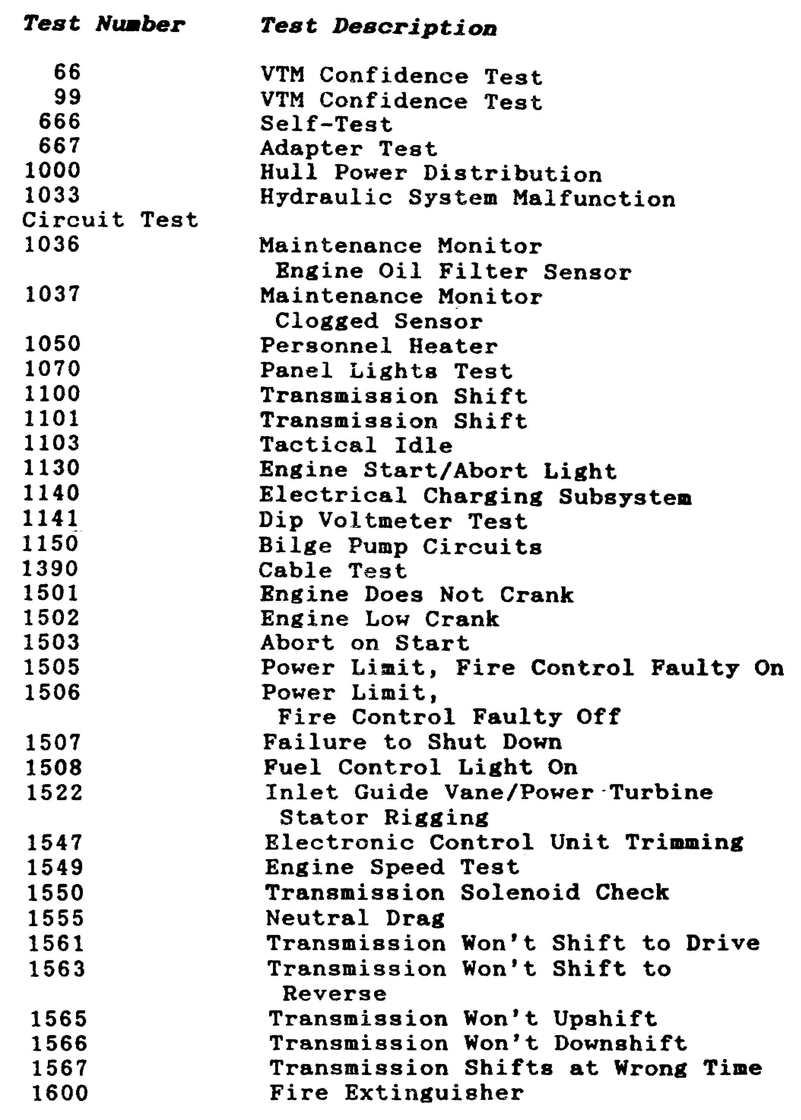

6
PRINC OF STE/M1 TEST SET--M1 TANK - OD 0471 - LESSON 1/TASK 1

Table 2. STE/M1 Turret Test Routines.

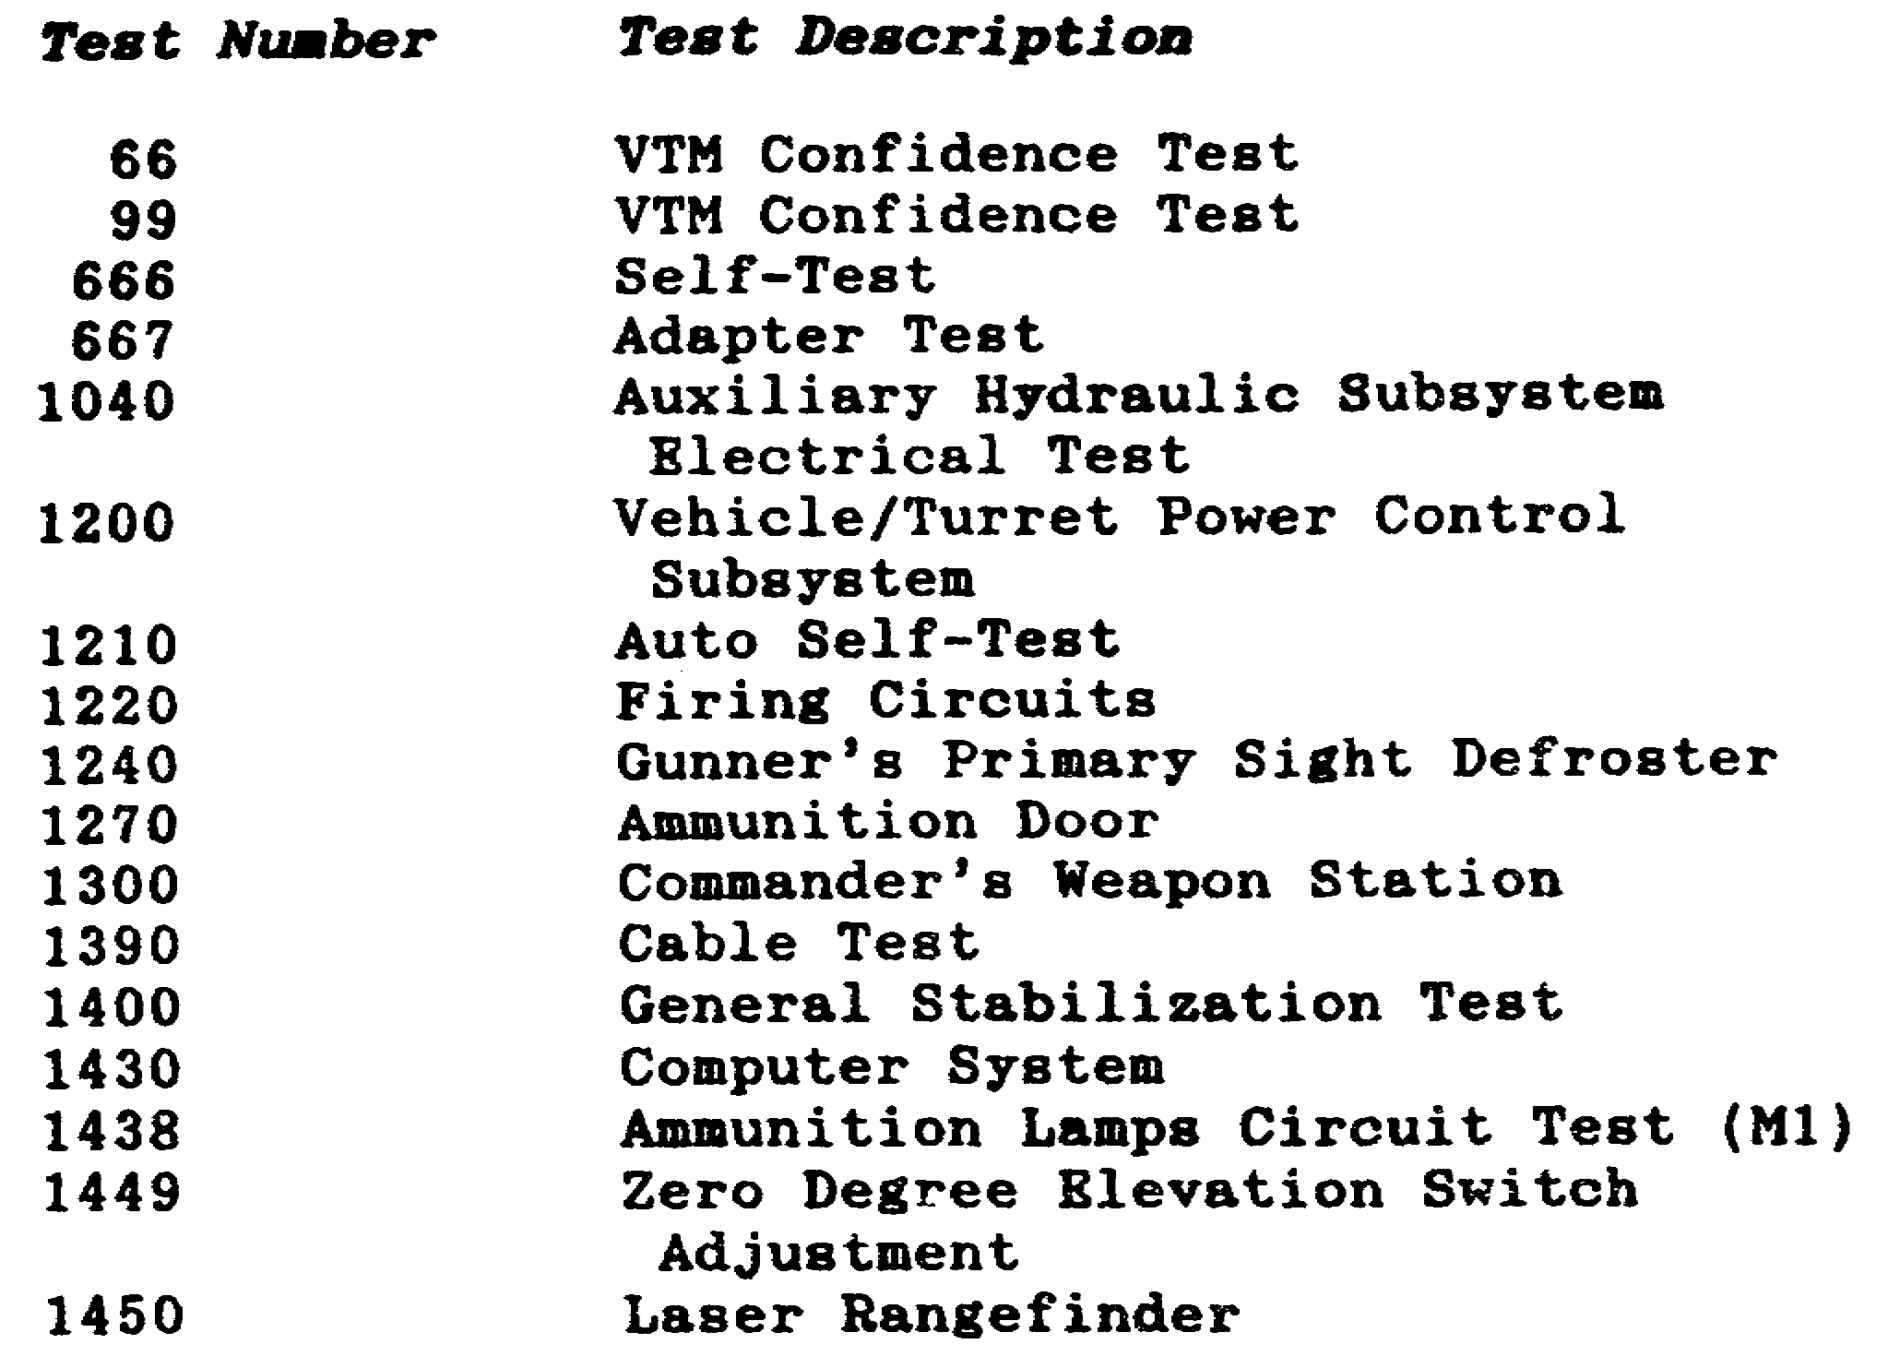

As the mechanic performs a test on the M1, using the STE/Mi-FVS, the test set indicates faulty components or subsystems on the SETCOM. Using the information provided in the appropriate TM, the mechanic determines the proper corrective action or follow-on tests to perform.

4. Conclusion

This gives some indication of the range of tests of which the STE/Mi-FVS is capable. In the next task, we will discuss the procedures for operating the STE/M1-FVS, including those for preparing the test set for use, and for performing an actual test on the M1 tank.

7
PRINC OF STE/M1 TEST SET--M1 TANK - OD 0471 - LESSON 1/TASK 2

LESSON 1

THE FUNCTION AND OPERATION OF THE
SIMPLIFIED TEST EQUIPMENT/M1 TEST SET

TASK 2. Describe the operation of the simplified test equipment/Ml test set.

CONDITIONS

Within a self-study environment and given the subcourse text, without assistance.

STANDARDS

Within three hours

REFERENCES

No supplementary references are needed for this task.

1. Introduction

The previous task introduced the STE/M1-FVS test set: a small computer which makes the electrical troubleshooting job on the M1 tank easier for the M1 tank systems mechanic.

This task will describe actual operating procedures for the STE/Ml-FVS as they relate to the M1 tank. STE/M1 setup and checkout procedures will be discussed, along with sample hull and turret test routines.

2. General STE/M1 Operating Information

a. Operation in Automated Mode. A test is begun by finding the number of the appropriate test from the fault symptom index of the system to be tested, in the applicable TM. The mechanic then enters the test number through the SETCOM keyboard (1), (figure 5, on the following page). The test number will appear on the SETCOM display (2), as it is entered. If an incorrect test number is entered, the mechanic pushes the CLEAR button

8
PRINC OF STE/M1 TEST SET--M1 TANK - OD 0471 - LESSON 1/TASK 2

(3) on the keyboard and enters the correct test number. When the complete test number is entered, the GO button (4) is pushed to start the automated test sequence.

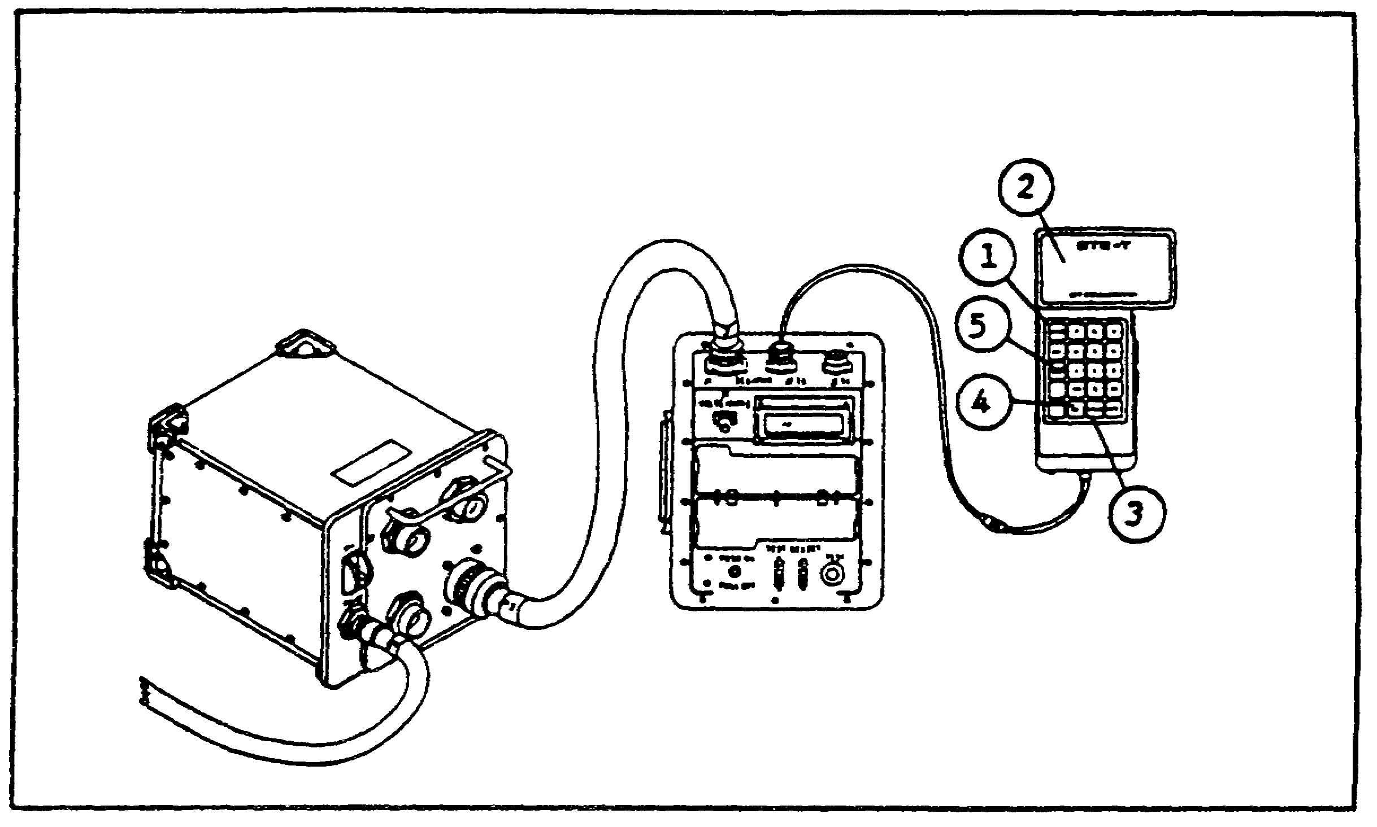

FIGURE 5. STE/M1 OPERATION IN AUTOMATED MODE.

The SINGLE STEP key (5, figure 5) is used to display a single test measurement. This key is not pushed unless the SETCOM displays an instruction to do so. Pushing the SINGLE STEP key during certain test sequences can cause faulty information to be displayed on the SETCOM.

o There are eight types of messages displayed on the SETCOM during automated testing.

(1) Test Start Messages. A test start message (figure 6, on the following page) is displayed every time an automated mode test number is entered on the SETCOM. The mechanic reads the message to be sure that the right test number is displayed. When the correct test number is displayed, the mechanic pushes the GO key to start the test.

(2) General Instruction Messages. General instruction messages, as in figure 7 on the following page, instruct the mechanic to do something either to the tank or to the test equipment. The messages are simple and do not need

9
PRINC OF STE/M1 TEST SET--M1 TANK - OD 0471 - LESSON 1/TASK 2



FIGURE 6. TEST START MESSAGE.

explaining. The mechanic presses the GO key to continue testing after carrying out the instruction.



FIGURE 7. GENERAL INSTRUCTION MESSAGE.

(3) Cable Instruction Messages. Cable instruction messages (figure 8, on the following page) tell the mechanic to perform an action, such as connecting test cables, assembling test adapters, or disconnecting tank wiring harnesses. The shorthand in which these messages are displayed can be difficult to understand. An inexperienced operator should go to the Cable Instruction Message Index, located at the end of each troubleshooting procedure in the TM, to find out exactly how to perform the cable hookup, assembly, or disconnect. After completing the cable instruction, the GO button is pressed to resume the test.

(4) Special Instruction Messages. Special instruction messages (figure 9, on the following page) usually tell the mechanic to do something to the equipment to aid the test. In many cases, the messages are short and it can be difficult to understand precisely what action is required. Therefore, the mechanic should always look at the Special Instruction Message Index, located at the back of each troubleshooting procedure, to find out what the message requires. Figure 10, on the following page, shows a particularly common special instruction message. The mechanic must always consult the Special Instruction Message Index when the message in figure 10 appears. The GO key is pushed after doing the requested action.

10
PRINC OF STE/M1 TEST SET--MI TANK - OD 0471 - LESSON 1/TASK 2

FIGURE 8. CABLE INSTRUCTION MESSAGE.

FIGURE 9. SPECIAL INSTRUCTION MESSAGE

FIGURE 10. SPECIAL INSTRUCTION MESSAGE.
(2 OF 2)

(5) Question Messages. Question messages (figure 11) ask the operator about various components in the tank. The mechanic answers the question by pressing the YES or NO key on the SETCOM to continue testing.

FIGURE 11. QUESTION MESSAGE.

(6) Information Messages. Information messages (figure 12, on the following page) tell the operator about situations to expect while a test is in progress. After reading the information, the mechanic presses the GO key.

(7) Test Termination Messages. Three kinds of messages signal the end of a test. The message shown in figure 13 on the following page, is displayed when no faults are found by the test.

11
PRINC OF STE/M1 TEST SET--M1 TANK - OD 0471 - LESSON 1/TASK 2

The STOP and CLEAR keys must be pushed before repeating the test, or beginning a new test.

FIGURE 12. INFORMATION MESSAGE.

FIGURE 13. TEST TERMINATION MESSAGE (1 OF 4).
The message shown in figure 14 is displayed when the test set isolates the problem to one faulty part.



FIGURE 14. TEST TERMINATION MESSAGE (2 OF 4).

If the display lists more than one faulty part, as in figure 15, a follow-on procedure must be performed to find out which of the listed units is faulty. Follow-on procedures are listed in the Fault Message Index, located at the end of each troubleshooting procedure.



FIGURE 15. TEST TERMINATION MESSAGE (3 OF 4).

12
PRINC OF STE/M1 TEST SET--M1 TANK - OD 0471 - LESSON 1/TASK 2

The message shown in figure 16 is used to end a test after special information has been given. The information message will be repeated by pushing the GO key. The STOP and CLEAR keys must be pushed to begin a new test.



FIGURE 16. TEST TERMINATION MESSAGE (4 OF 4).

(8) Error Messages. During testing, the error messages listed in table 3 may be displayed on the SETCOM. These messages tell the operator that the test procedures have not been followed correctly, or that there is a possible test set problem.

NOTE

If a message is displayed repeatedly after everything has been checked, IDS maintenance must be notified. If a similar message not in the table is repeatedly displayed, the mechanic must refer to the technical manual for the STE/M1-FVS.

Table 3. STE/M1 Error Messages.

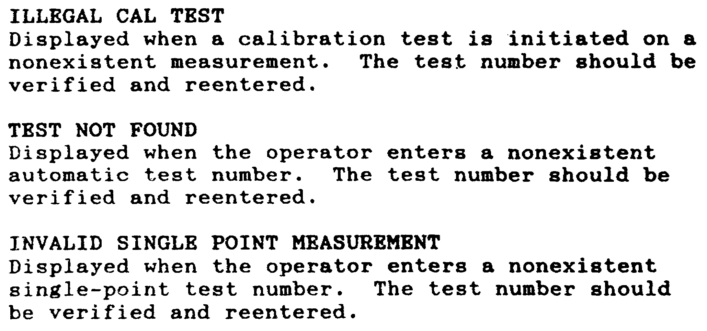

13
PRINC OF STE/Mi TEST SET--M1 TANK - OD 0471 - LESSON 1/TASK 2

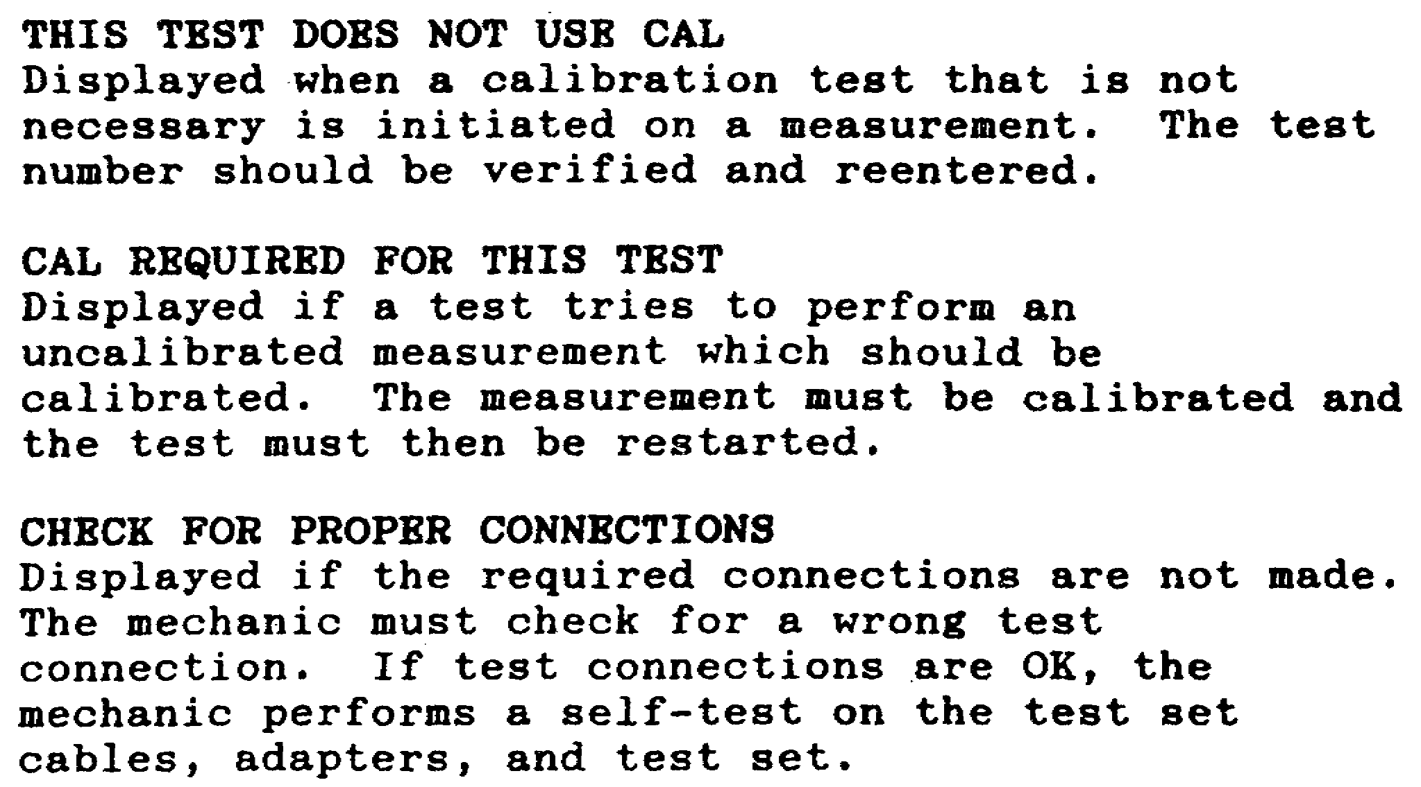

b. Standard STE/ICE Mode. The VTM in the STE test set may be used as a multimeter to measure alternating current (AC) or direct current (DC) voltages and currents, frequencies, resistances, and continuity. General purpose testing may be applied to any vehicle or other equipment with the following limits:

o 0-30 inches of mercury (in. Hg) vacuum
o 0-30 in. Hg vacuum variation
o 0-50 in. Hg pressure
o 0-150 in. water pressure drop
o 0-1000 pounds per square inch gage (psig) pressure
o 0-45 volts DC
o 0-1500 amperes DC
o 0-40,000 ohms resistance
o 0-35 volts AC
o 0-700 amperes AC
o 40-500 Hertz (Hz) frequency

STE/ICE, it should be noted, stands for Simplified Test Equipment for Internal Combustion Engines. The VTM in a STE/ICE set is essentially the same as the test set in the STE/M1-FVS,

14
PRINC OF STE/M1 TEST SET--M1 TANK - OD 0471 - LESSON 1/TASK 2

which is why the STE/M1 can function in a standard STE/ICE mode.

3. Operator's Controls and Indicators, STE/Ml Common Hardware

a. VTM Controls and Indicators. (Figure 17).

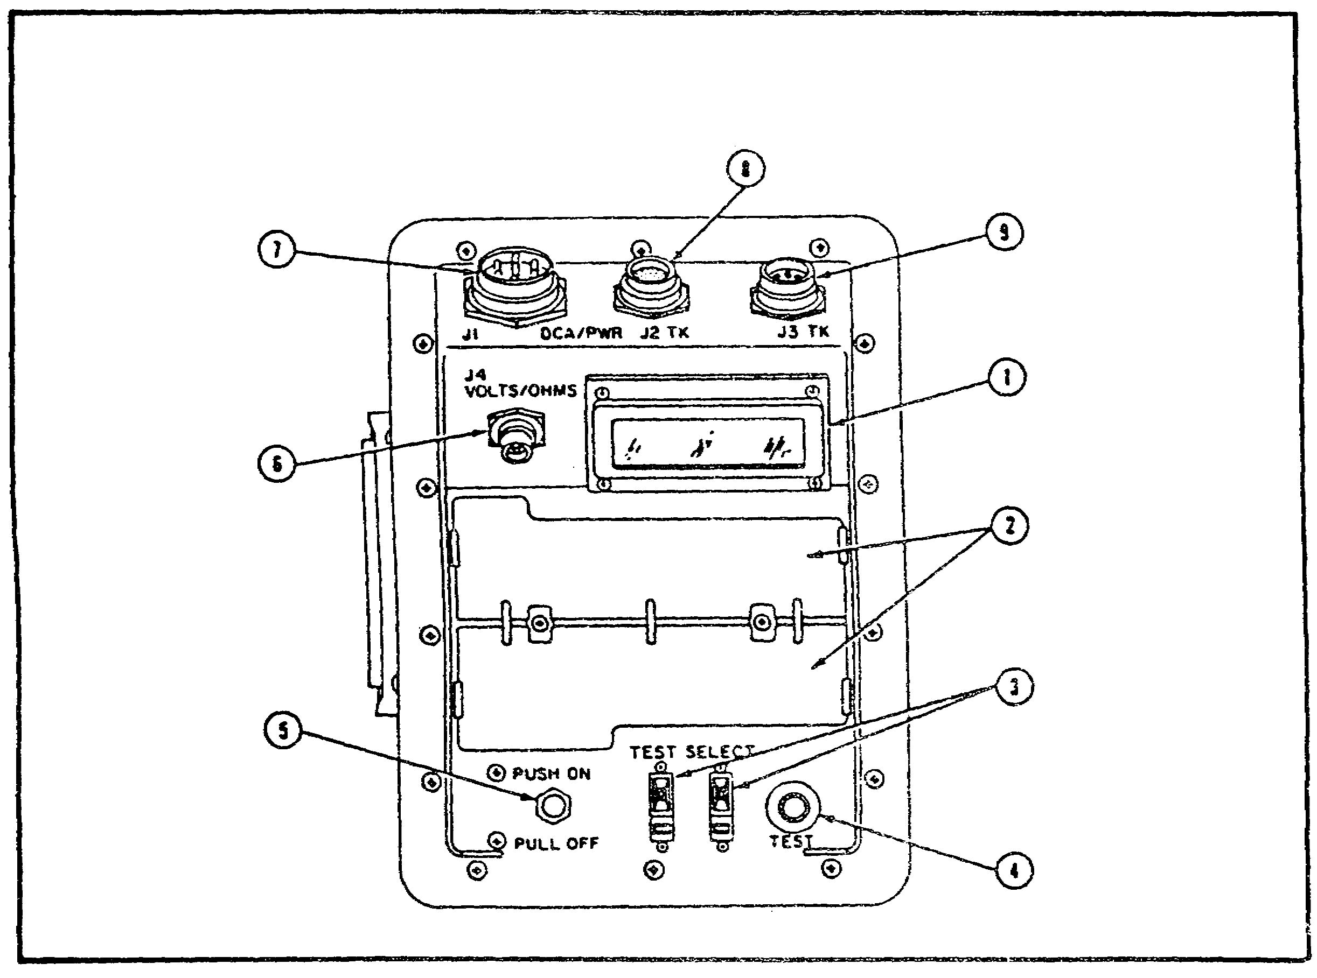

FIGURE 17. VTM CONTROLS AND INDICATORS.

(1) Display. The display shows status and error codes at the start of the self-test when the VTM, CIB, and SETCOM are all connected.

(2) Flip Cards. The flip cards are part of the standard VTM. They are not used during STE/M1 testing.

(3) TEST SELECT Thumbwheel Switches. These switches select the test being performed, either on the VTM itself, or when the VTM is being used in standard STE/ICE mode.

15
PRINC OF STE/M1 TEST SET--M1 TANK - OD 0471 - LESSON 1/TASK 2

(4) TEST Pushbutton Switch. This switch is used to start a test, either for a VTM confidence test, or when the VTM is being used in STE/ICE mode.

(5) PUSH ON/PULL OFF Circuit Breaker. This controls power to the VTM. It functions as an on/off switch.

(6) J4 VOLTS/OHMS Connector. This connector is used for a cable with test leads. It is used when performing voltage and resistance tests.

(7) J1 DCA/PWR Connector. The VTM receives signals and power from the CIB through this connector. In STE/ICE mode, diagnostic connector assemblies (DCAs) can be connected to this jack to run vehicle tests.

(8) J2 TK Connector (CX309 Cable). The SETCOM is connected to the VTM via this connector.

(9) J3 TK Connector. Transducers from the VTM transducer kit (TK) are connected to the VTM at this jack. Any TK transducer can be connected to the J3 connector.

b. CIB Controls and Indicators. (Figure 18).
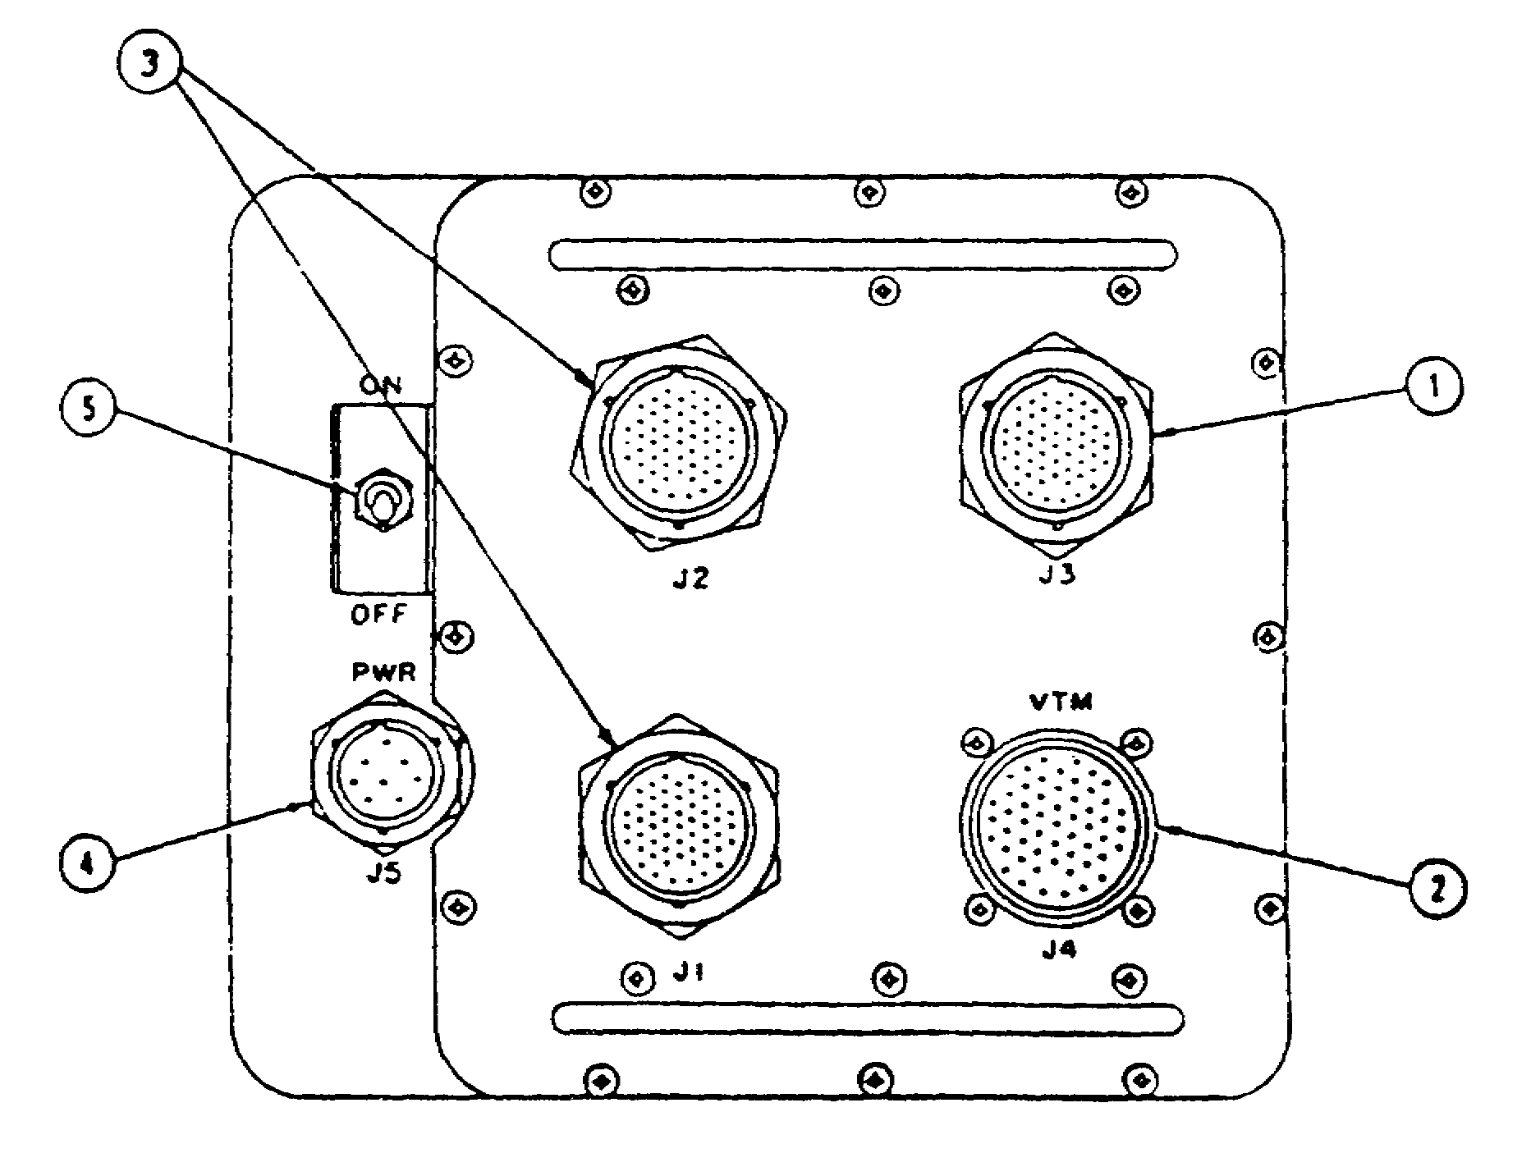

FIGURE 18. CIB CONTROLS AND INDICATORS.

16
PRINC OF STE/M1 TEST SET--M1 TANK - OD 0471 - LESSON 1/TASK 2

(1) J3 Connector. This connects to a cable which connects the CIB to the fire extinguisher test system and stabilization system for the M1 tank. It is also used for special tests on the M2 and M3 FVS vehicles.

(2) J4 Connector. This jack is for the cable that interconnects the CIB and the VTM. The test signals and power to the VTM come from this connector.

(3) J1, J2 Connectors. The common-use test cables are connected to these points to connect the CIB to vehicle subsystems.

(4) J5 PWR Connector. Power to the CIB comes through a cable connected to J5.

(5) ON/OFF Circuit Breaker. Power to the CIB is controlled by this circuit breaker. As in the VTM, the circuit breaker functions as an on/off switch.

c. SETCOM Controls and Indicators. (Figure 19.)

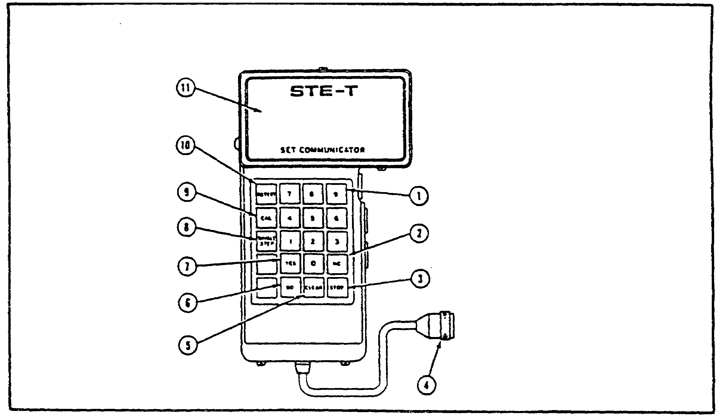

FIGURE 19. SETCOM CONTROLS AND INDICATORS.

(1) Number Keys 0 through 9. Test numbers are entered with these keys.

(2) NO Key. The operator enters a NO answer to a question on the SETCOM display with this key.

17
PRINC OF STE/M1 TEST SET--M1 TANK - OD 0471 - LESSON 1/TASK 2

(3) STOP Key. Any time the operator wishes to stop a test before it is completed, he presses this key.

(4) Connector. This connects to J2 of the VTM.

(5) CLEAR key. The CLEAR key has three functions:

o Clear a test number entered using the number keys

o Start a new test after pressing STOP.

o Clear the display after a fault message.

(6) GO Key. The GO key has three functions:

o Start a test after the test number is entered through the number keys.

o Continue a test after pressing STOP.

o Continue a test as instructed by the display.

(7) YES Key. This key is used to give a YES answer to a question on the SETCOM display.

(8) SINGLE STEP Key. This key is not used by the operator except as instructed by the SETCOM.

(9) CAL Key. This key is not used during vehicle testing; it is used during the self-test.

(10) RETEST key. This key allows the operator to repeat the last completed test step which had an action message. Any operator instructions are also displayed when the RETEST key is pressed.

(11) Display. This is a 39-character alphanumeric display which gives self-test and vehicle test related information and action messages for the operator when performing tests.

4. M1-Peculiar Hardware for STE/M1-FVS

There are no operator's controls and indicators for the Ml-peculiar hardware of the STE/M1. The M1-peculiar hardware consists of a number of adapters and cable assemblies which will be examined in the following paragraphs.

18
PRINC OF STE/M1 TEST SET--M1 TANK - OD 0471 - LESSON 1/TASK 2

a. Stabilization/Turret Accessories. The stabilization/turret accessories assembly consists of electrical DBAs, branched cables, plugs, electrical adapters, and a transducer. The stabilization/turret accessories assembly is shown, without its transit case, in figure 20.

b. Engine/Transmission/Fire Extinguisher/Hull Accessories. The engine/transmission/fire extinguisher/hull accessories assembly (figure 21, on the following page) consists of test fittings and adapters, transducers, and cables. An infrared simulator and a dummy load amplifier are included in the assembly for testing the fire extinguisher system.

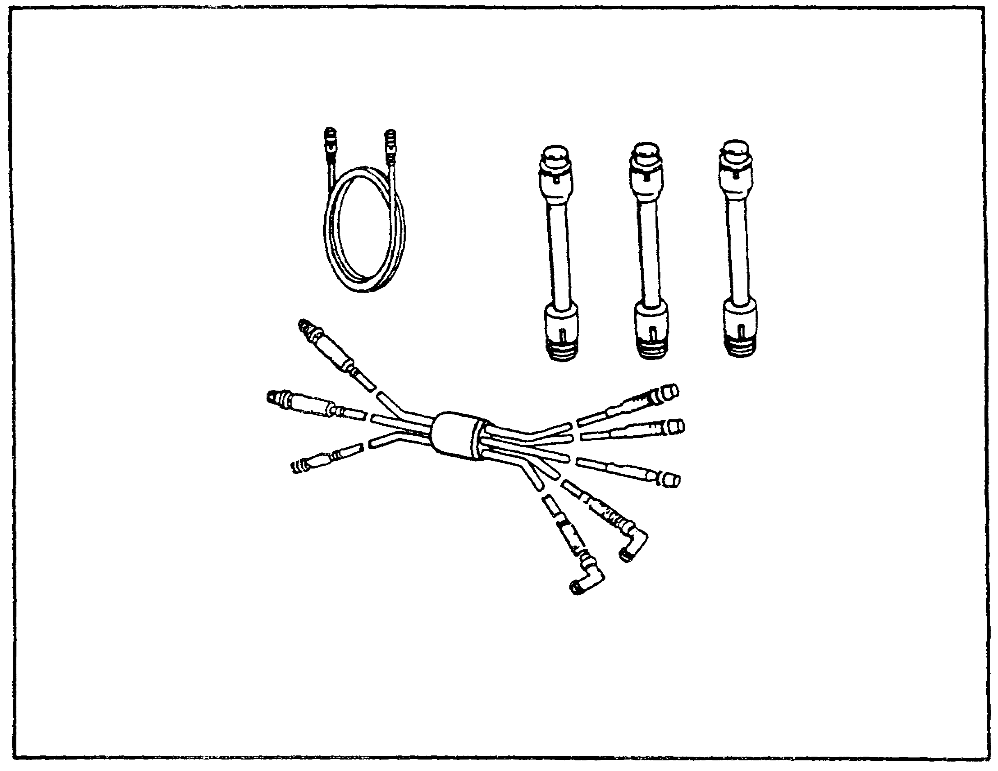

FIGURE 20. STABILIZATION/TURRET ACCESSORIES.

c. Hull Test Accessories and Turret Test Accessories Assemblies. These assemblies consist of test adapters for performing tests on hull systems and turret systems respectively. Typical hull test adapters and turret test adapters are shown in figures 22 and 23 on page 21.

19
PRINC OF STE/M1 TEST SET--M1 TANK - OD 0471 - LESSON 1/TASK 2

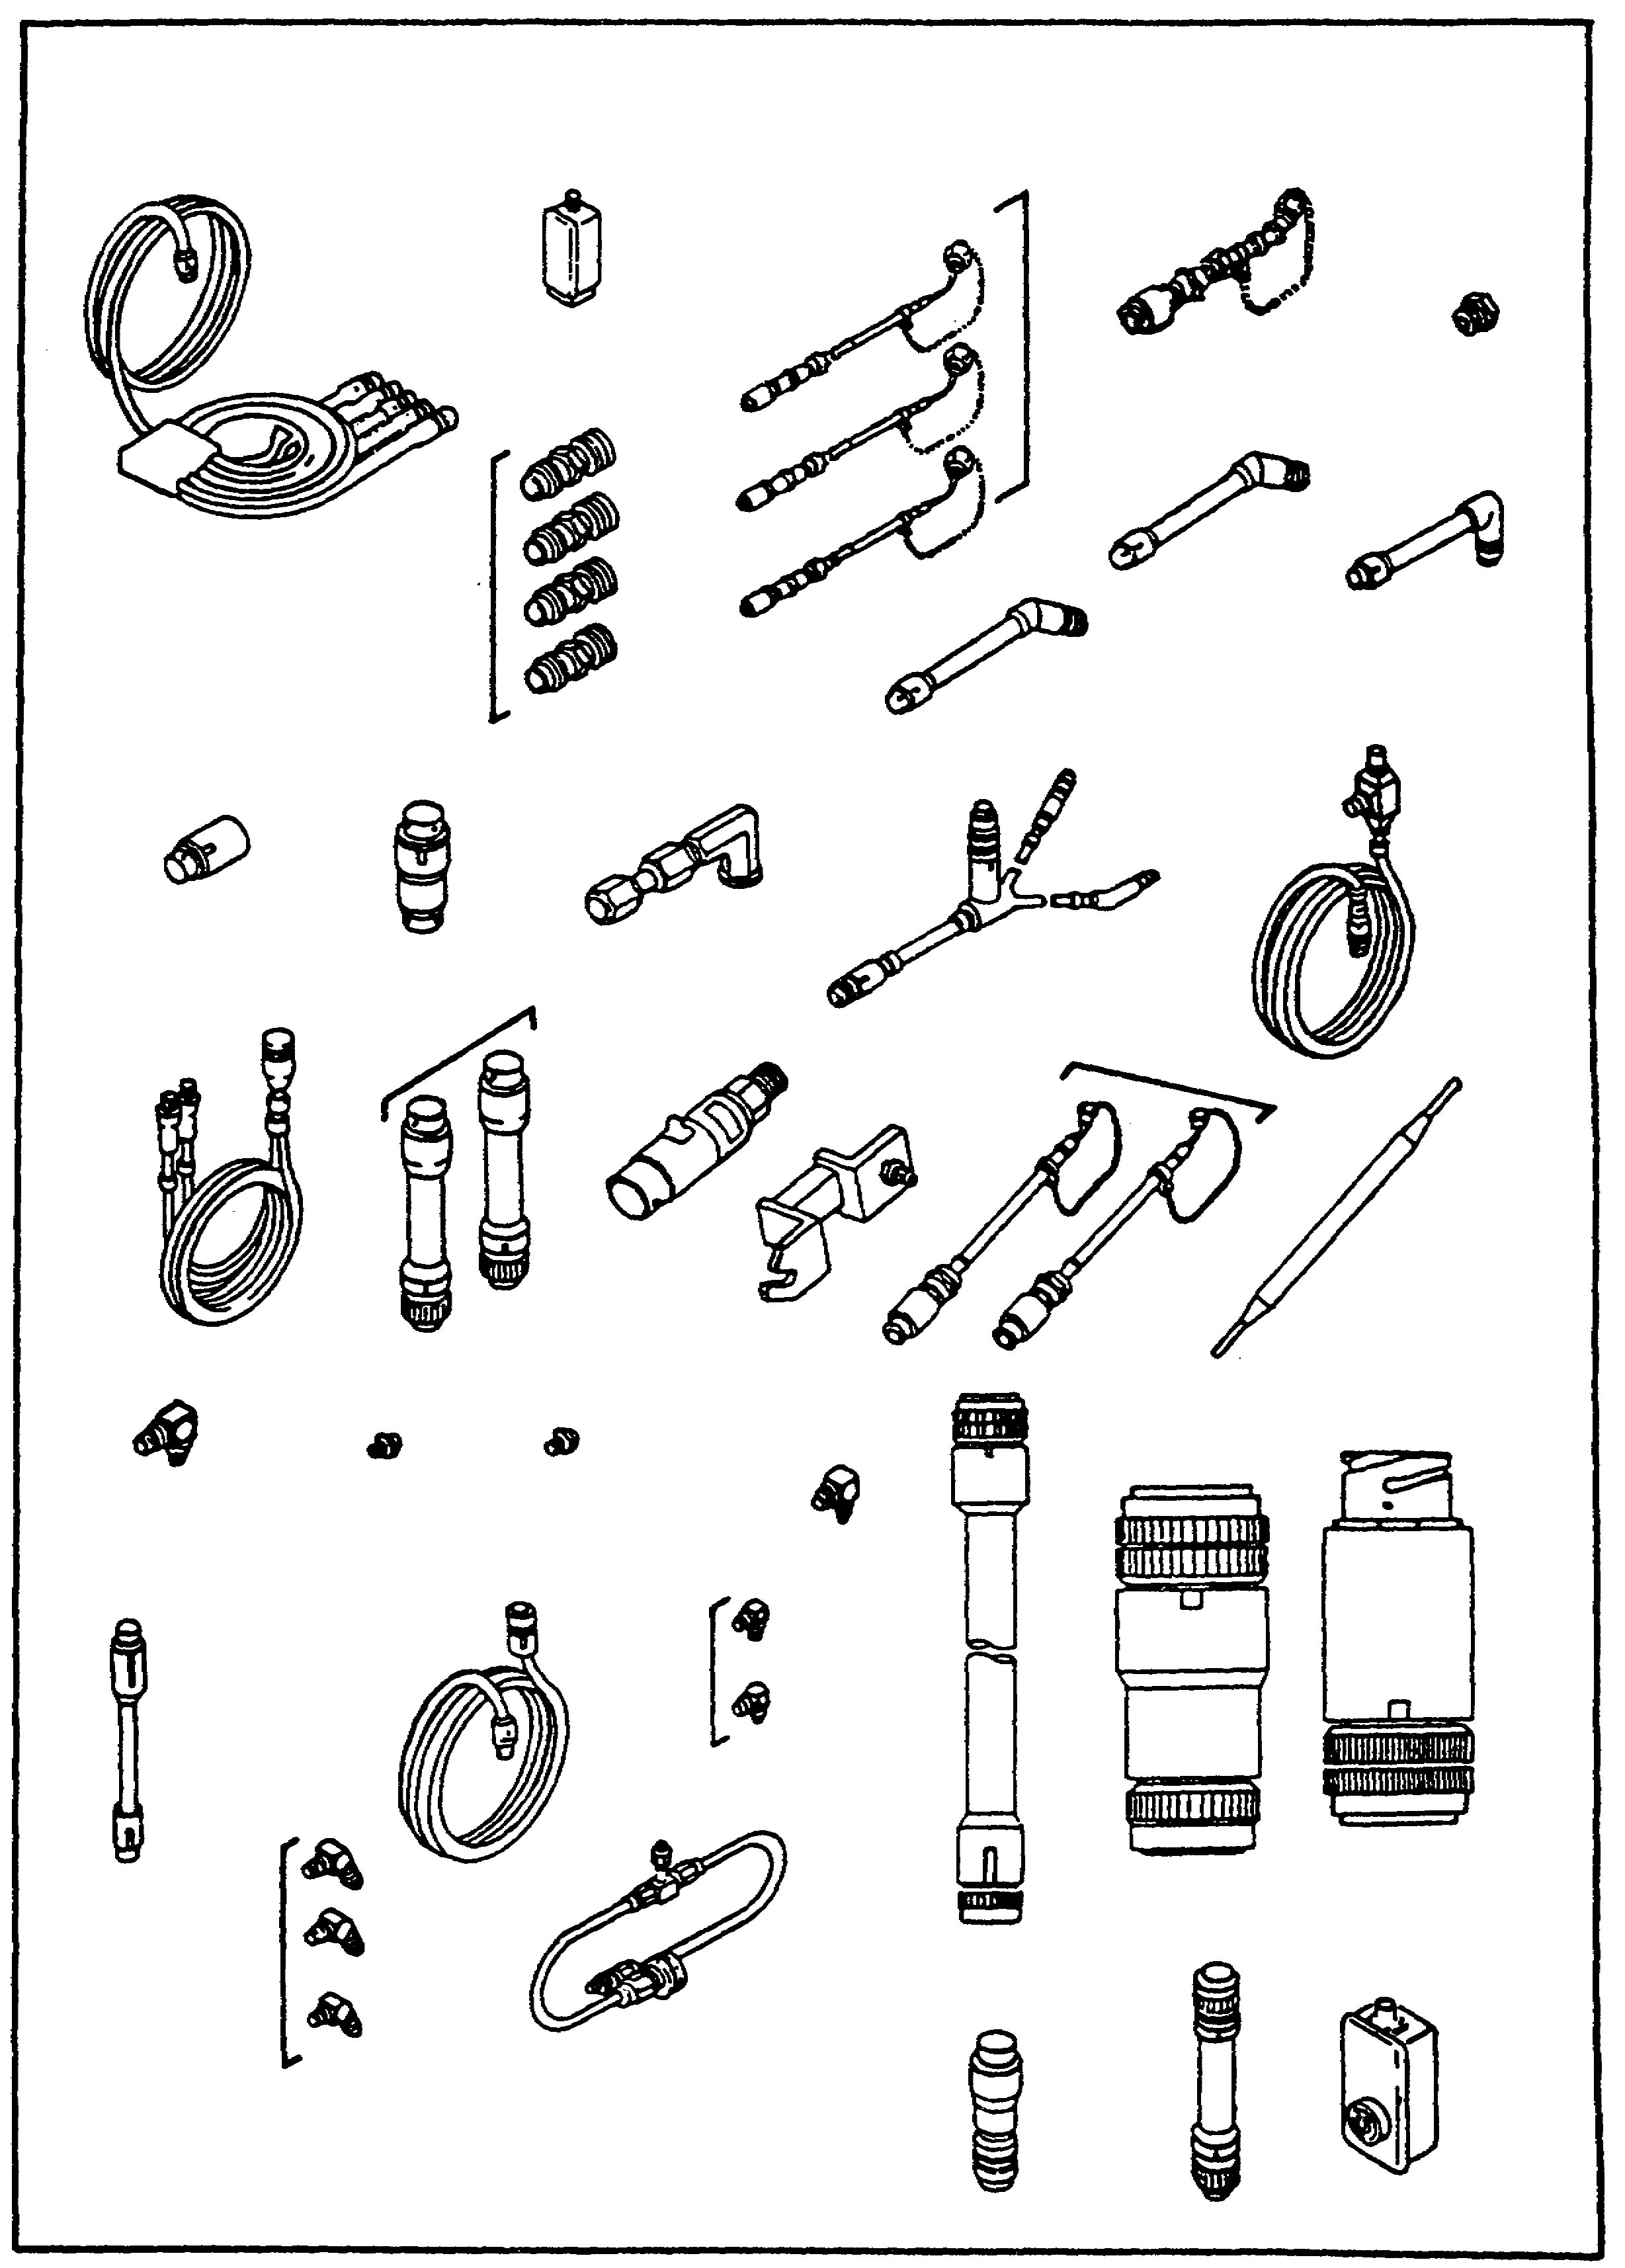

FIGURE 21. ENGINE/TRANSMISSION/FIRE
EXTINGUISHER/HULL ACCESSORIES.

20
PRINC OF STE/M1 TEST SET--M1 TANK - OD 0471 - LESSON 1/TASK 2

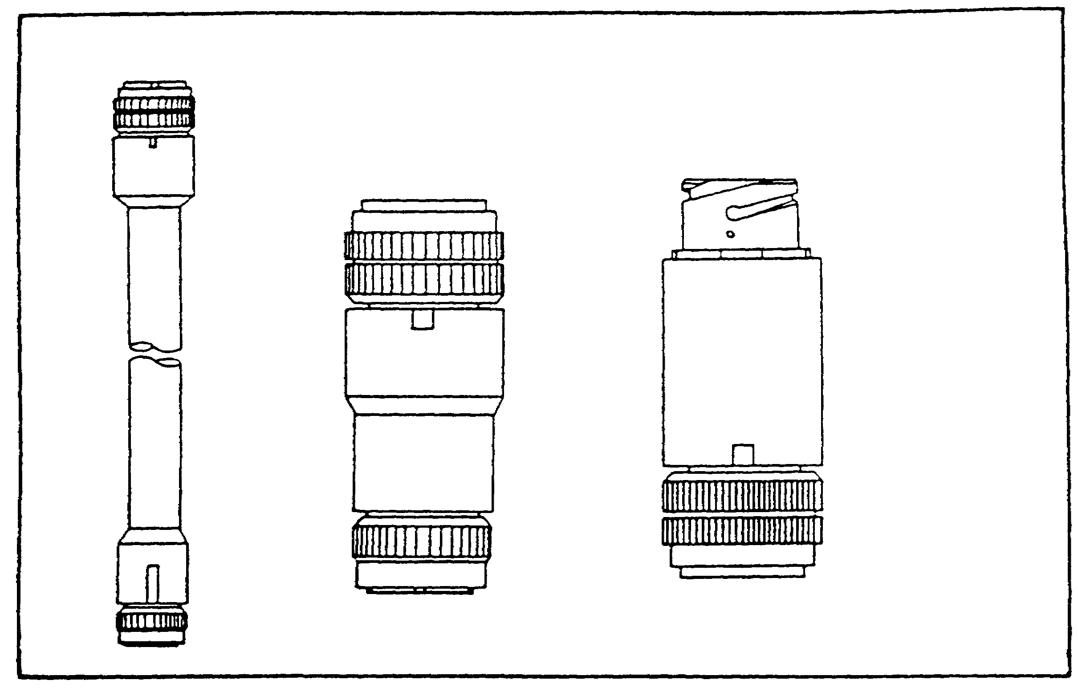

FIGURE 22. TYPICAL HULL TEST ADAPTERS.

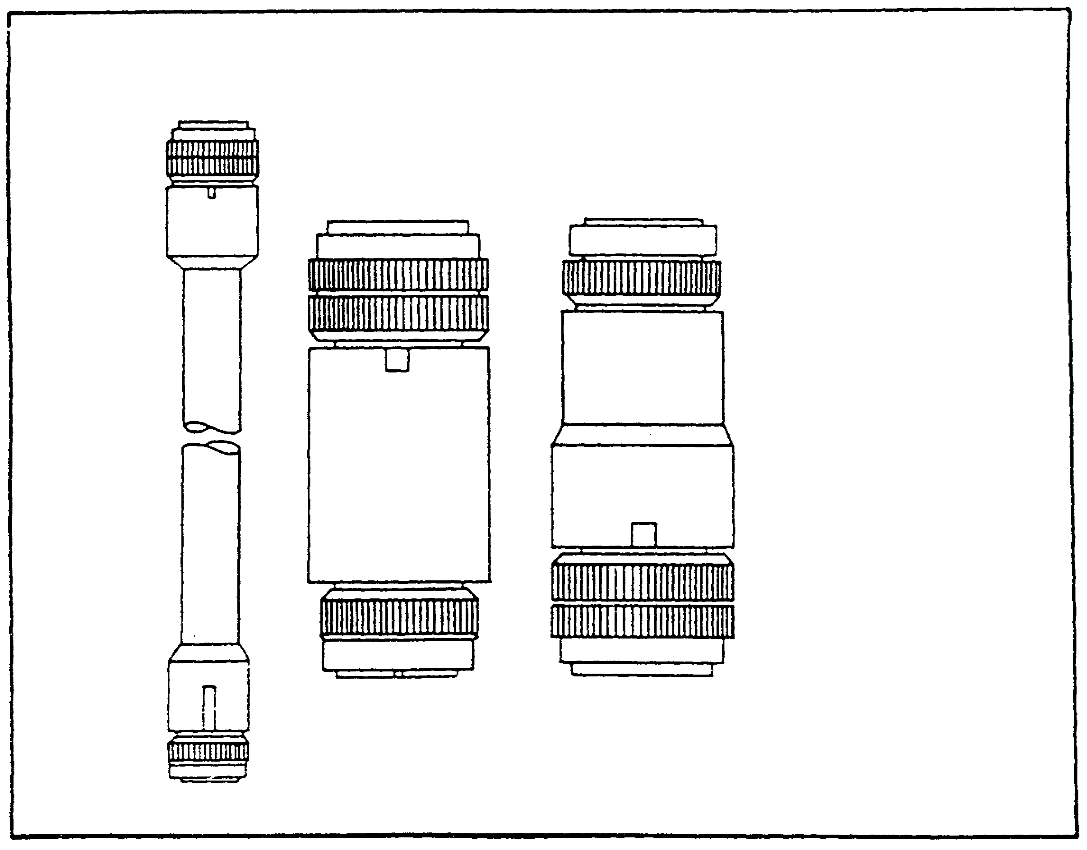

FIGURE 23. TYPICAL TURRET TEST ADAPTERS.

21
PRINC OF STE/M1 TEST SET--M1 TANK - OD 0471 - LESSON 1/TASK 2

5. Preparing the STE/M1 For Use

In discussing the steps for preparing the STE/M1 for use, we will take as an example the steps for a standard cable hookup for hull tests. The steps for a standard turret test cable hookup are similar. In later sections, we will look at both a typical hull test and a typical turret test.

NOTE

Prior to conducting any test with the STE/M1, a self-test must be conducted.

a. Hookup and Self-Test. The CIB (1), (figure 24), VTM (2), SETCOM (3), cable assembly CX309 (4), cable assembly W1 (5), and cable assembly CX306 (6), are placed on the tank hull (7) near the driver's hatch (8). Plug P1 (9) of cable W1 (5) is connected to J1 (10) on the VTM (2). Plug P2 (11) of cable W1 (5) is connected to J4 (12) on the CIB.

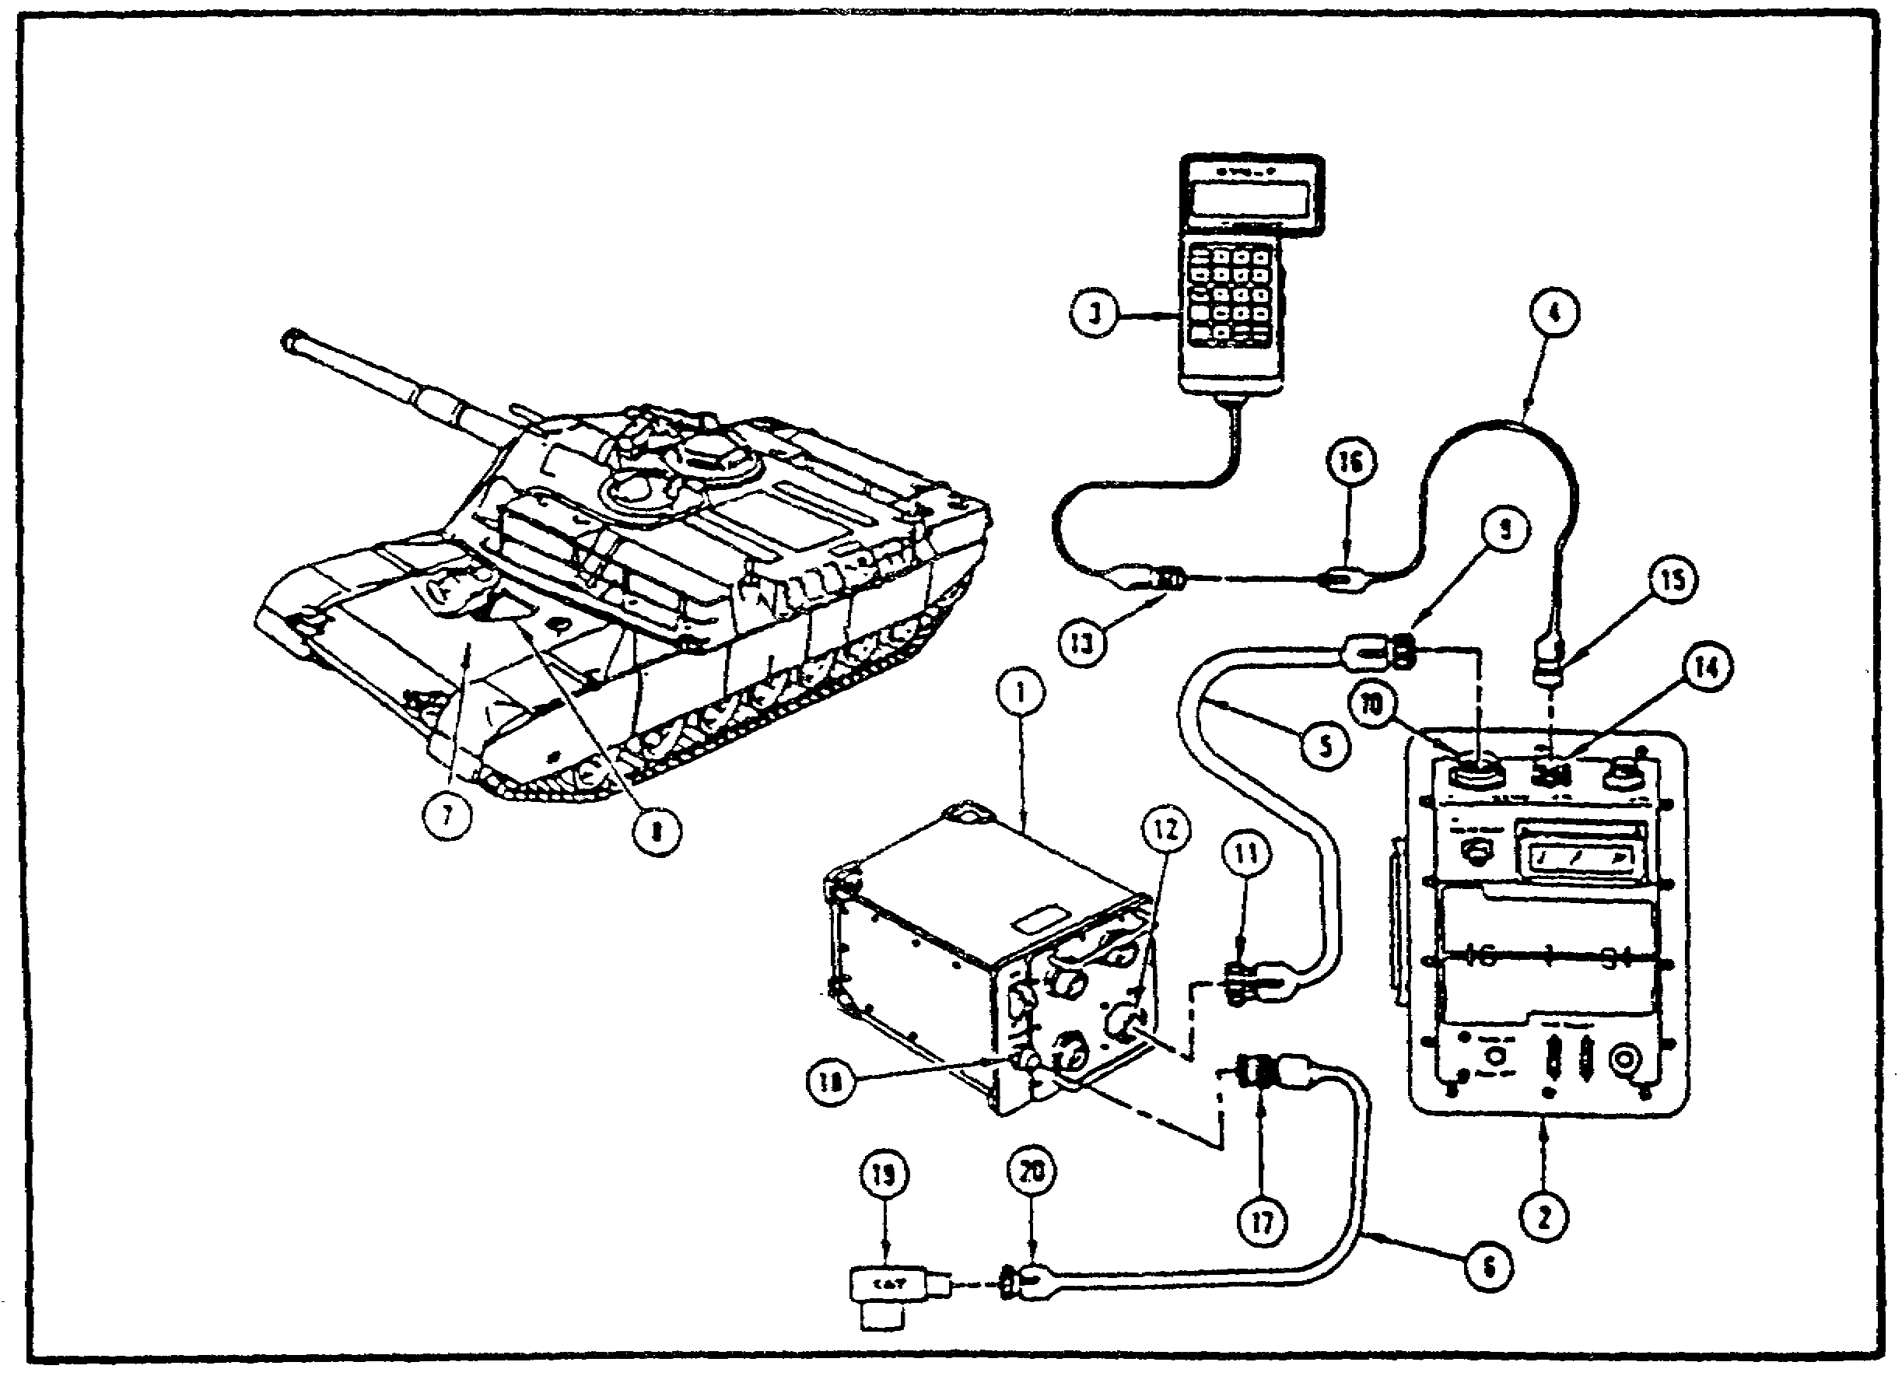

FIGURE 24. HULL TEST STANDARD CABLE HOOKUP
(1 OF 3).

22
PRINC OF STE/M1 TEST SET--M1 TANK - OD 0471 - LESSON 1/TASK 2

NOTE

Cable CX309 (4), (figure 24 on the previous page) is a 25-foot extension cable for the SETCOM (3); if not needed, the SETCOM cable (13) is connected directly to J2 (14) on VTM (2).

If the SETCOM extension cable is used, plug P1 (15), (figure 24, on the previous page) of cable CX309 (4) is connected to J2 (14) on the VTM (2). The SETCOM cable (13) is connected to plug P2 (16) of cable CX309.

NOTE

Cable assembly plugs are commonly identified by using the number of the cable assembly and the number of the plug. Thus, plug P2 of cable CX309 would be referred to as CX309-P2. This subcourse will use this notation from this point on.

After the SETCOM (3), (figure 24, on the previous page) is connected to the VTM (2), either directly or through extension cable CX309 (4), CX306-P2 (17) is connected to J5 (18) on the CIB (1). NATO adapter CA1 (19) is connected to CX306-P1 (20).

The STE/M1 operator then checks the condition of the battery indicators in the M1 tank. With all battery indicators showing green, NATO adapter CA1 (1), (figure 25) is plugged into the slave receptacle (2) on the power distribution box (3). The PWR switch (4) on the CIB (5) is set to ON. The circuit breaker (6) on the VTM (7) is pushed ON. The VTM display (8) should show .8.8.8.8 for about one second, then change to -----.

The TEST SELECT switches (1) and (2), (figure 26) on the VTM (3) are set to 66, then the TEST button (4) on the VTM is pressed. The display (5) should show 0066. The TEST SELECT switches are then set to 99 and the TEST button is pressed again. The display will flash some numbers and then show PASS.

The VTM TEST SELECT switches (1) and (2), (figure 26) are set to 00 and the TEST button (4) is pressed. The display (6) on the SETCOM (7) is checked for the message STE/M1 FVS CLEAR UNIT? The

23
PRINC OF STE/M1 TEST SET--M1 TANK - OD 0471 - LESSON 1/TASK 2

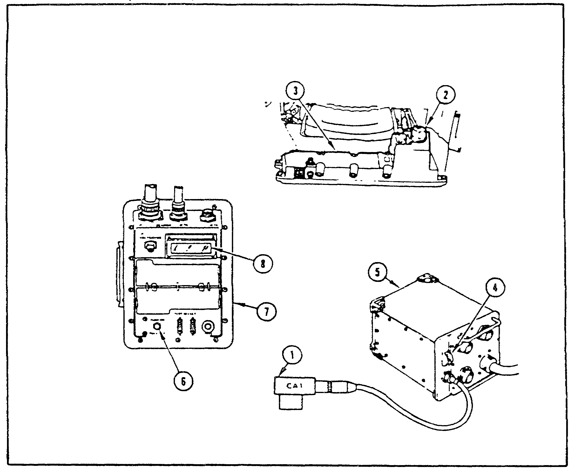

FIGURE 25. HULL TEST STANDARD CABLE HOOKUP
(2 OF 3).

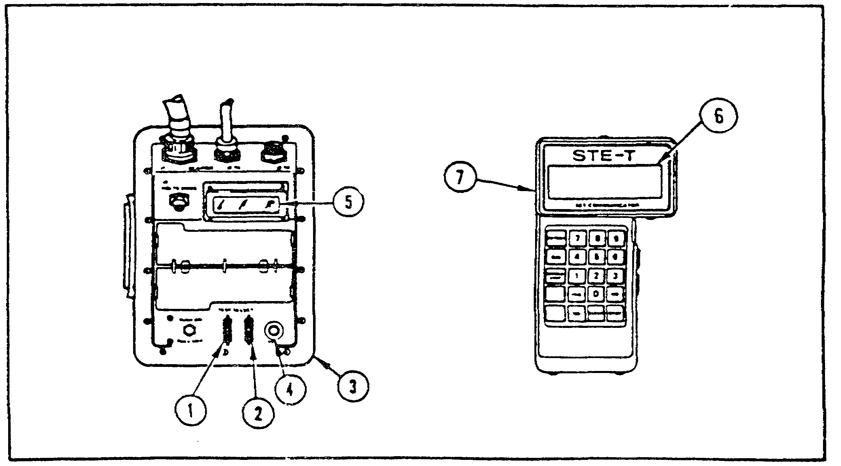

FIGURE 26. HULL TEST STANDARD CABLE HOOKUP
(3 OF 3).

24
PRINC OF STE/M1 TEST SET--M1 TANK - OD 0471 - LESSON 1/TASK 2

operator presses the CLEAR key on the SETCOM. The display will show ENTER TEST NUMBER: . The self-test code 666 is entered into the SETCOM and the operator presses the GO key. The display will show TEST 666 SELF-TEST.

The GO key is pressed and the message REVISION DATE XXXXXX appears in the display. The Xs here represent a number, which changes when the test program is updated. The operator presses the GO key again and the display shows REMOVE CABLES FROM CIB J1, J2, and J3. After ensuring that no cables are connected to those connectors on the CIB, the operator presses the GO key again and the SETCOM displays TEST IN PROGRESS PLEASE WAIT.

At this point, assuming that the VTM is operating properly, the next VTM display should be BUTTON TEST: PRESS RETEST. The operator presses the RETEST key and the display shows BUTTON TEST: PRESS 7. The operator responds in the same way to the action messages displayed by the SETCOM display. These messages will instruct the operator to press, in this order, the 8, 9, CAL, 4, 5, 6, SINGLE STEP, 1, 2, 3, YES, 0, NO, CLEAR, and GO keys.

After the GO key is pressed the last time, the SETCOM shows:

DISPLAY TEST
0123456789

The operator presses the GO key and the display changes to:

ABCDEFGHIJKLM
NOPQRSTUVWXYZ

The GO key is pressed again, and the display shows:

abdcefghijklm
nopqrstuvwxyz

The GO key is pressed again, the display should show:

When the GO key is pressed again, the display shows:

25
PRINC OF STE/M1 TEST SET--M1 TANK - OD 0471 - LESSON 1/TASK 2

The operator presses the GO key again. The SETCOM display instructs the operator to INSPECT CIB CONNECTORS J1 & J2. After reading the message, the operator presses the GO key. The SETCOM asks ARE PINS BENT OR BROKEN? If there are no bent or broken pins, the operator presses the NO key. The SETCOM responds with TEST IN PROGRESS PLEASE WAIT. The operator then waits for the display to change.

If no fault message appears, the SETCOM will display CONNECT CX304 TO CIB J1. After making the connection, the operator presses the GO key. The SETCOM displays CONNECT PLUG TA301 TO CX304. After making the connection, the operator presses the GO key; the SETCOM responds with TEST IN PROGRESS PLEASE WAIT.

The display should next show REMOVE PLUG TA301 FROM CX304. After removing the plug, the operator presses the GO key. The SETCOM answers with TEST IN PROGRESS PLEASE WAIT. After the display changes, the SETCOM should show CABLE CX304 OK. The mechanic presses the GO key and the display prompts him to CONNECT CX305 TO CIB J2. After making the requested connection, the GO key is pressed. This leads to the prompt CONNECT PLUG TA301 TO CX305. The GO key is pressed again and the SETCOM responds with TEST IN PROGRESS PLEASE WAIT.

When the display changes this time, it will show REMOVE PLUG TA301 FROM CX305. The plug is removed and the GO key is pressed. After displaying TEST IN PROGRESS PLEASE WAIT, the SETCOM should show CIB CABLES OK. The GO key is pressed again, and the SETCOM responds with TEST FINISHED PUSH STOP AND CLEAR. When the operator follows this instruction, the SETCOM will display ENTER TEST NUMBER: . If a self-test is all that is being performed, the operator does not need to enter a test number.

If the STE/M1 is being shut down at this point, the power switches on the CIB and VTM are set to OFF and all cables and adapters are disconnected from the tank to conclude the procedure.

b. Adapter Test. After performing the setup and self-test procedures on the STE/M1, the adapter test must be run before actually performing a test on a vehicle. With the STE/M1 connected to the vehicle, but with the VEHICLE MASTER POWER

26
PRINC OF STE/M1 TEST SET--M1 TANK - OD 0471 - LESSON 1/TASK 2

switch OFF, the test number 667 is entered into the SETCOM at the prompt ENTER TEST NUMBER: .

The GO key is pressed after entering the test number 667, and the SETCOM displays TEST 667 ADAPTER TEST. The operator presses the GO key and the SETCOM displays WHAT ADAPTER? CA. The adapter test is begun by entering the number 455 into the SETCOM and pressing the GO key. The SETCOM displays ADAPTER PAIR TO BE TESTED: CA455 & CA456. Only one number of the adapter pair needs to be entered. The operator responds to the ADAPTER PAIR message by pressing the GO key. The SETCOM then shows USE: CA455, CA456, AND TWO CX308.

When the operator has read this message and pressed the GO key, the SETCOM prompts the operator to ASSEMBLE CIB CABLE, CX308 AND CA455. The operator executes the instruction and presses the GO key. The SETCOM then tells the operator to CONNECT CIB CABLE TO CIB J1. Once he has done this, the operator presses the GO key. The STE/M1 answers with ASSEMBLE CIB CABLE, CX308 AND CA456.

The operator assembles the cable as requested and presses GO. The SETCOM shows CONNECT CIB CABLE TO CIB J2. The operator then plugs cable CX305 into J2 on the CIB and presses GO. The SETCOM then tells the operator to CONNECT CA455 TO CA456. After connecting the adapters as requested and pressing GO, the operator should see the word GOOD on the SETCOM display. If, instead, the display reads FAULTY ADAPTER OR DBA, the operator must perform fault isolation on the adapters and cables as directed by the STE/M1. Procedures for performing this fault isolation are given in TM 9-4910-751-14-1.

When the word GOOD appears on the SETCOM, the mechanic presses GO. The SETCOM responds with TEST OK and waits for the GO key to be pressed. The STE/Mi then responds with WANT TO PERFORM ANOTHER ADAPTER TEST? Adapter tests must be performed on each pair of adapters that comes with the M1-peculiar hardware assemblies. A table listing the adapter pairs is found in TM 9-4910-751-14-1. If all adapter pairs have been tested, the operator presses the NO key. The SETCOM responds with TEST FINISHED PRESS STOP AND CLEAR. Before proceeding to a vehicle test, the STOP and CLEAR keys must be pressed.

27
PRINC OF STE/M1 TEST SET--M1 TANK - OD 0471 - LESSON 1/TASK 2

Now that the procedures for setting up the STE/M1 and running the self-test and adapter test have been discussed, we proceed to example tests on the hull and the turret.

6. M1 Testing with the STE/M1

Typically, the STE/M1 is not the first item of test equipment the mechanic is directed to use on the M1 tank. Most troubleshooting tasks in the M1 hull and turret troubleshooting manuals require the mechanic to perform a number of common troubleshooting steps; such as checking for loose connectors, before reaching for the STE/M1. When we look at the hull and turret tests which follow, we will begin at the point where the STE/M1 is introduced into the task. Of course, no actual troubleshooting or repairs should be performed without the actual technical publications at hand.

a. Hull Test: Fire Extinguisher System Found Faulty During Tank Operation. After connecting the STE-M1, the operator enters test number 1600 into the SETCOM and presses GO. The SETCOM responds with TEST 1600 FIRE EXTINGUISHER. The operator presses GO.

At this point, the SETCOM could display one of three types of messages. It may first display a general instruction message. It may display a cable instruction message, such as an assemble, disconnect, reconnect, or remove message. Or, it may show a fault message. For now, we will assume that none of these messages are displayed.

What the operator would see, then, is the question CREW COMPARTMENT FIRE SYSTEM TEST? The mechanic responds YES or NO to the question, depending upon which system he wants to test. For now, our mechanic will answer YES.

After the YES key is pressed, the SETCOM may display a message similar to those the operator may have seen when the test number was first entered. If no messages are seen, the SETCOM will then display CREW SYSTEM TEST OK PRESS GO.

When GO is pressed, the SETCOM will ask WANT TO CHECK OTHER FIRE EXT SYSTEM? The mechanic answers YES or NO; we will answer YES. When YES is pressed, the SETCOM will ask CREW COMPARTMENT FIRE

28
PRINC OF STE/M1 TEST SET--M1 TANK - OD 0471 - LESSON 1/TASK 2

SYSTEM TEST? again. This time, the NO key is pressed and the SETCOM asks ENGINE COMPARTMENT FIRE SYSTEM TEST?, meaning, "Do you want to check the first-shot engine compartment fire extinguisher system?" The mechanic answers YES to this question by pressing the YES key.

As before, the SETCOM could respond with a general instruction message, a cable instruction message, a special instruction message, or a fault message. For example, the mechanic could see the message FAULTY 1 SHOT 160318. This instructs the mechanic that the first shot valve and bottle assembly is defective and must be replaced.

b. Turret Test: Gunner's Primary Sight Defroster Subsystem Found Faulty During Tank Operation. After making the proper connections to the M1 tank and preparing the STE/M1 for operation, the test number 1240 is entered into the SETCOM. The SETCOM display shows TEST 1240 GPS DEFROSTER and the mechanic presses the GO key. As before, on the hull, the SETCOM display could show one of a number of messages. A possible cable instruction is CONNECT CIBJ1 (CX305) TO TNB TJ1 (CA206). This requires the mechanic to consult the cable instruction message index in the technical manual (TM) for the directions to respond to this message.

If this message were seen, the mechanic would connect P1 on adapter CA206 to TEST 1 on the turret networks box; P1 of CIB cable CX305 would be connected to P2 on adapter CA206; finally, P2 on CIB cable CX305 would be connected to CIB-J1.

After performing the action requested by the cable instruction message, the mechanic presses the GO key and waits for the SETCOM to display a message. The mechanic may see a message such as FAULTY GPS OR 1W203. This means that the defroster problem is in either the gunner's primary sight (GPS) or wiring harness lW203. A follow-on procedure would have to be performed. The fault message index in the TM directs the mechanic to the paragraph with the appropriate follow-on procedures to determine which component is at fault.

Once the faulty component is located and the appropriate corrective action is taken, the mechanic repeats the test by pressing the STOP and CLEAR keys and entering the test number 1240 and pressing the GO key. The SETCOM, as before, will

29
PRINC OF STE/M1 TEST SET--M1 TANK - OD 0471 - LESSON 1/TASK 2

display TEST 1240 GPS DEFROSTER to verify that the GPS defroster test is to be performed. If the corrective action solved the problem, the SETCOM will respond to the GO key with the message NO FAULTS FOUND. The M1 tank systems mechanics then knows that the problem with the GPS defroster has been solved.

7. Conclusion

The M1 tank systems mechanic knows that the M1 is a complicated vehicle. The STE/M1-FVS is a handy computer-controlled diagnostic instrument that makes the job of locating defective components quicker and easier. This subcourse has presented the functions and operating procedures for the STE/M1-FVS. M1 tank systems mechanic who are familiar with the STE/M1, and use it in their troubleshooting tasks, will find their tasks moving more quickly in finding and correcting faults, allowing vehicles to be returned to service sooner.

30
PRINC OF STE/M1 TEST SET--M1 TANK - OD 0471 - LESSON 1/PE 1

PRACTICAL EXERCISE 1

1. Instructions

On a plain sheet of paper, write down the answers to the following questions. When you have answered them, turn the page and check your answers.

First Requirement

(1) What name is given to the vehicle test meter (VTM), the controllable interface box (CIB), the set communicator (SETCOM), and associated adapters and cable assemblies, when they are all considered as a group?

(2) What name is given to the combination of the stabilization/turret accessories, the engine/transmission/fire extinguisher/hull accessories, the hull test accessories, and the turret test accessories?

(3) Including self-tests, adapter tests, and confidence tests, how many total tests can the STE/M1-FVS perform?

Second Requirement

(1) Name the STE/M1-FVS operating modes.

(2) List the eight message types which the STE/M1 SETCOM displays.

(3) What does the message mean and what must the operator do when the SETCOM displays CAL REQUIRED FOR THIS TEST?

(4) The following tests are not listed in the order they must be performed. List them in the sequence in which they must occur:

Adapter test

Confidence test 66

Self-test

Confidence test 99

31
PRINC OF STE/M1 TEST SET--M1 TANK - OD 0471 - LESSON 1/PE 1

(5) What must the operator do if the SETCOM displays a cable instruction message after a test number is entered?

(6) What is the meaning of a STE/M1 message such as FAULTY GPS OR lW203?

32
PRINC OF STE/M1 TEST SET--M1 TANK - OD 0471 - LESSON 1/PE 1

LESSON 1. PRACTICAL EXERCISE - ANSWERS

First Requirement

(1) The common hardware.

(2) The Ml-peculiar hardware.

(3) 50: Two VTM confidence tests
One self-test
One adapter test
13 turret tests
33 hull tests

Second Requirement

(1) Automated mode, STE/ICE mode.

(2) Test start, general instruction, cable instruction, special instruction, question, information, test termination, error.

(3) The message means that a test is trying to perform an uncalibrated measurement which must be calibrated; the operator must calibrate the instrument for the measurement and restart the test.

(4) Confidence test 66, confidence test 99, self- test, adapter test.

(5) The operator must consult the cable Instruction Message Index in the technical manual for the specific instructions relating to the observed cable instruction.

(6) A message such as this means that the STE/M1 has traced the fault to a number of possible components, and that follow-on procedures must be performed to isolate the faulty component.

33
PRINC OF STE/M1 TEST SET--M1 TANK - OD 0471 - REFERENCES

REFERENCES

34
PRINC OF STE/M1 TEST SET--M1 TANK - OD 0471 - REFERENCES

REFERENCES

The following documents were used as resource materials in developing this subcourse:

TM 9-2350-255-20-1-2-1
TM 9-2350-255-20-1-2-2
TM 9-2350-255-20-1-2-3
TM 9-2350-255-20-2-2-1
TM 9-2350-255-20-2-2-2
TM 9-2350-255-20-2-2-3
TM 9-4910-751-14-1

35

